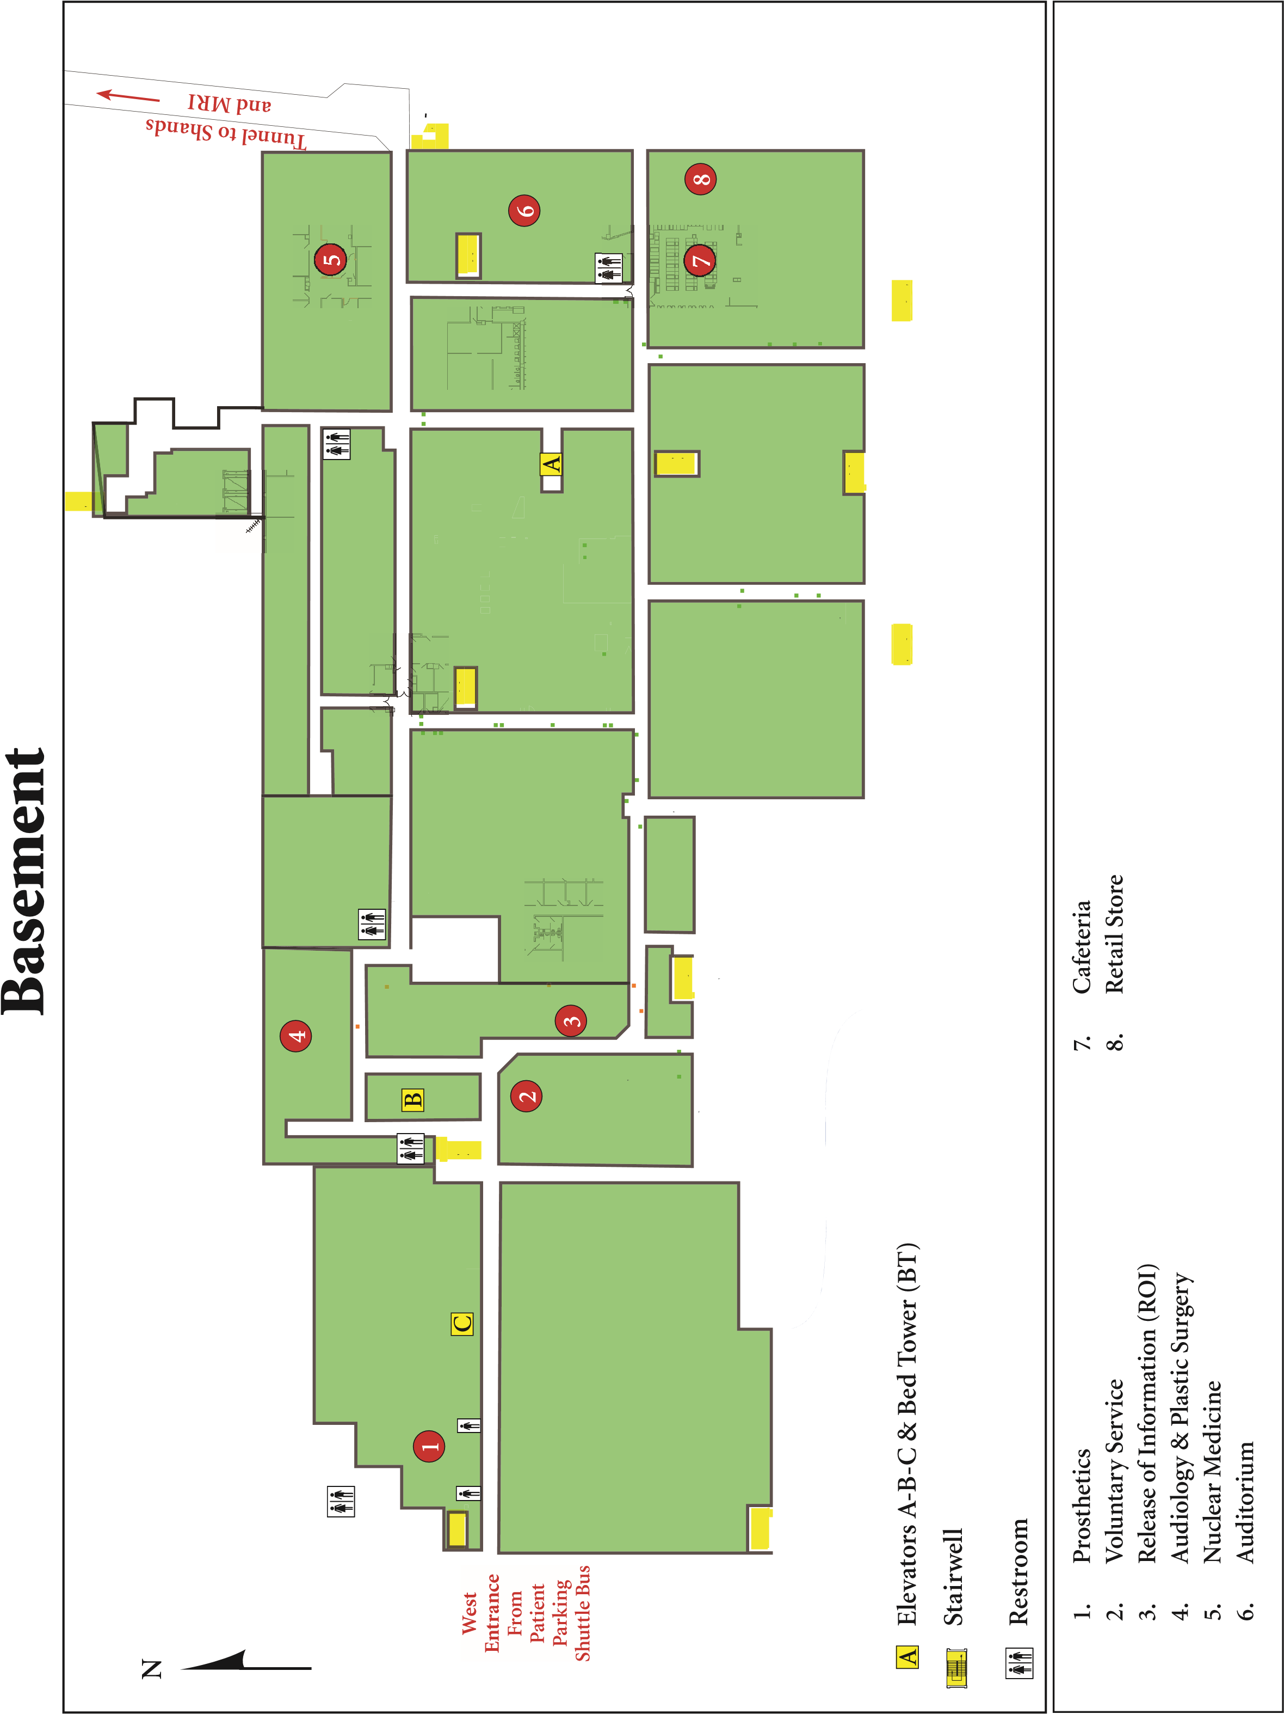

**EB-59>>>**

**ENTER HERE >>>>**