Things to Know before you use the TurnItIn LTI

ASSIGNMENT PREVIOUSLY SET TO USE TURNITIN AS AN OPTION IN THE SUBMISSIONS TYPE BOX MUST BE EDITED AND SET TO USE THE EXTERNAL TURNITIN TOOL. If this is not done, no review will take place.

The TurnItIn LTI at this time
- Will Not let students upload more than one file for review.
Resubmission can be allowed. However, if you allow students to do resubmits, TurnItIn only keeps, the last version. If you are going to review a draft and then the final submission and you want to see both documents, you will have to create 2 assignments. One for the draft and one for the final submission. (use duplicate assignment from three little dots)
- Will Not Work with Group Assignments
- Will Not Allow multiple submission dates
Differentiated due dates are not supported within the same assignment. If you need to create an alternate time or date you will need to create a duplicate assignment for the student(s).
- Will Not Review documents less than 20 words, more than 400 pages or files larger than 40MB
- Will Not Review unsupported file types
TurnItIn supports common file types but will not accept submissions for unsupported files types. (see supported file types in the Create an Assignment PDF).
- Will not Use Canvas Rubric Tool unless created prior to assigning External tool.
TurnItIn has its own rubrics tool, available in the TurnItIn settings. If you want to use the Canvas Rubrics tool the rubric must be added before applying the External Tool Submission Type.

Video Notes: Please read before watching the video.
- There are now 2 edits screens. The instruction video shows TurnItIn set to open in new tab.
The edit screen you are familiar with which includes the Canvas options for the assignment and the edit screen for TurnItIn. The TurnItIn edit screen provides options for the specific way in which the tool will review documents, such as what is being compared, whether students can resubmit, whether students can see their results. Once you make the original determination about these settings, you can choose to use them as the defaults for your course. Select the OPEN IN A NEW TAB option in the Submissions Type box of the Assignment. This will provide a separate tab for modifying TurnItIn and a clearer picture of when you are in Canvas and when you are in Turnitin.
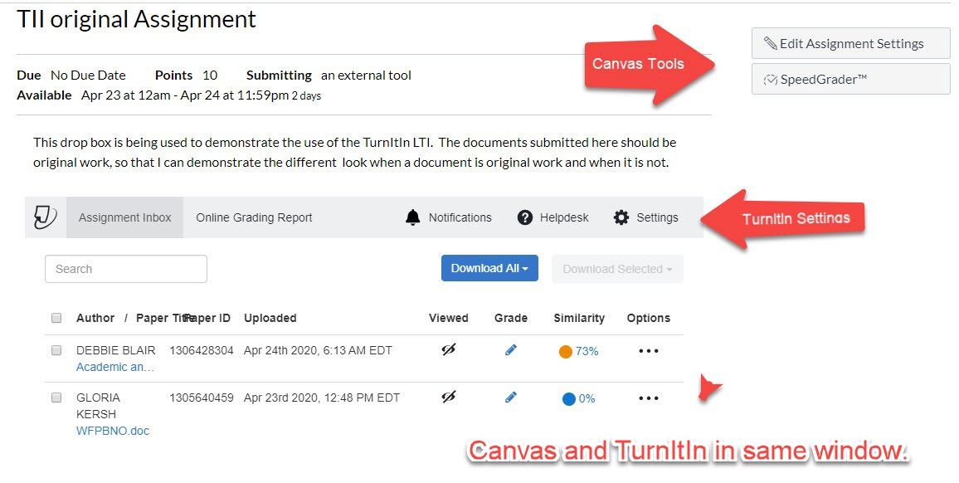
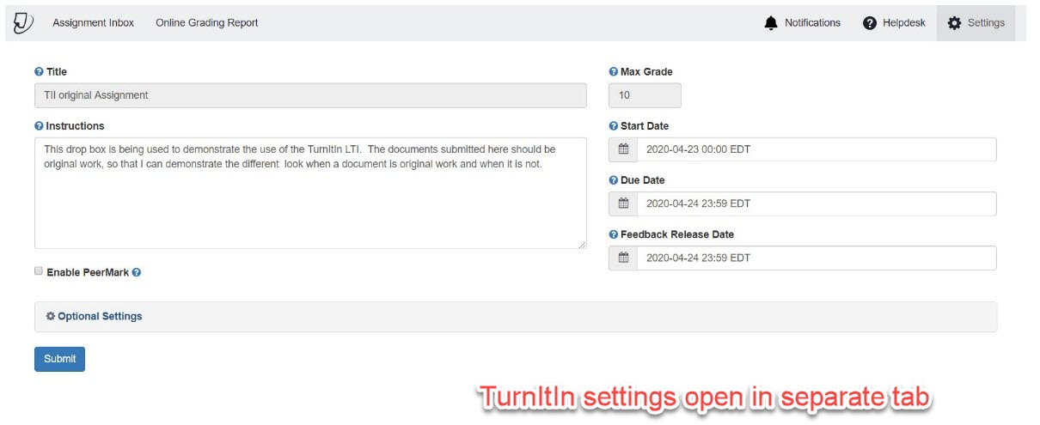

- Instructions should appear in the instruction box on both settings. Type the Instructions in the Canvas Assignment and then Copy them to the TurnItIn settings.
- Once the Turnitin settings for the assignment have been determined, SAVE SETTINGS for future TurnItIn work at the bottom of the Settings window.

