SUBCOMMITTEE ON SHARED GOVERNANCE

02/01/2020

Final Draft of Survey Format

**SURVEY DRAFT**

***\*\*Please note that text in blue is for committee use only*** *(to be deleted from actual survey)*

**SURVEY INTRODUCTION SECTION**

**SHARED GOVERNANCE AT SANTA FE COLLEGE**

This brief survey is being sent to you by your adjunct representatives in the Santa Fe College Senate. We are working with the college administration to address part-time faculty and staff concerns. To that end, we are proposing an increase to our representation in shared governance. We are interested in your views, and hope to get your input on some important potential changes. The results of this survey will be used to prioritize initiatives for enhancing equity and inclusion among part-time faculty and staff. **Your responses on this survey are completely anonymous.**

**QUESTIONS SECTION**

**SURVEY QUESTIONS: ADJUNCT VERSION (send only to adjuncts)**

FIRST… We would like to know your views about the following concerns previously expressed by adjunct faculty. *Please rank the following (1-8) in order of relative importance to you, with 1 being the most important:*

 Converting some adjunct positions into new full-time faculty positions

 Salary increases/bonuses comparable to those of full-time faculty

 Paid time off (sick days, bereavement, etc.)

 Access to employee health insurance benefits

 Regular teaching performance evaluations

Increased job security

 Replacing BENCOR (FICA alternative) with federal Social Security benefits

Other not listed here (please specify) _______________________________________

NEXT… Regarding those concerns you just ranked, *please help us better understand the relative strength of your choices by selecting a number on the scales below for each issue.*

|  |  |  |  |  |  |  |  |  |  |  |  |  |  |  |  |  |  |  |  |  |  |  |  |  |  |  |  |  |  |
| --- | --- | --- | --- | --- | --- | --- | --- | --- | --- | --- | --- | --- | --- | --- | --- | --- | --- | --- | --- | --- | --- | --- | --- | --- | --- | --- | --- | --- | --- |
| |  |  |  |  |  |  |  |  | | --- | --- | --- | --- | --- | --- | --- | --- | | 1. Converting some adjunct positions into new full-time faculty positions is | | | | | | | | |  | not at all important |  |  |  |  | extremely important |  | |  |  |  |  |  |  |   2. Salary increases/bonuses comparable to those of full-time faculty would have | | | | | | | |
|  | no impact at all  on my life |  |  |  |  | a huge impact  on my life |  |
|  |  |  |  |  |  |
| 3. Access to employee health insurance benefits would affect my situation | | | | | | | |
|  | not at all |  |  |  |  | enormously |  |
|  |  |  |  |  |  |
| 4. Paid time off (sick days, bereavement, etc.) is | | | | | | | |
|  | not at all  important |  |  |  |  | extremely  important |  |
|  |  |  |  |  |  |

|  |  |  |  |  |  |  |  |
| --- | --- | --- | --- | --- | --- | --- | --- |
| 5. Regular evaluations of my teaching performance at SF are | | | | | | | |
|  | not at all necessary |  |  |  |  | absolutely necessary |  |
|  |  |  |  |  |  |

|  |  |  |  |  |  |  |  |
| --- | --- | --- | --- | --- | --- | --- | --- |
| 6. A provision that provides better job security for teaching at SF would | | | | | | | |
|  | not affect  my life at all |  |  |  |  | be life  changing |  |

|  |  |  |  |  |  |  |  |
| --- | --- | --- | --- | --- | --- | --- | --- |
| 7. Replacing BENCOR (FICA alternative) with federal Social Security benefits | | | | | | | |
|  | doesn’t matter  at all |  |  |  |  | matters a  great deal |  |
|  |  |  |  |  |  |

|  |  |  |  |  |  |  |  |
| --- | --- | --- | --- | --- | --- | --- | --- |
|  |  |  |  |  |  |  |  |
| 8. The ‘other’ concern that I wrote in myself is | | | | | | | |
|  | not important  (or did not write one) |  |  |  |  | extremely important |  |
|  |  |  |  |  |  |

**SURVEY QUESTIONS: A&P VERSION (send only to PT A&P)**

FIRST… We would like to know your views about the following concerns previously expressed by part-time staff. *Please rank the following (1-7) in order of relative importance to you, with 1 being the most important:*

 Converting some part-time staff positions into new full-time positions

 Salary increases/bonuses comparable to those of full-time staff

 Paid time off (sick days, bereavement, etc.)

 Access to employee health insurance benefits

 Regular job performance evaluations

Increased job security

Other not listed here (please specify) _______________________________________

NEXT… Regarding those concerns you just ranked, *please help us better understand the relative strength of your choices by selecting a number on the scales below for each issue.*

|  |  |  |  |  |  |  |  |  |  |  |  |  |  |  |  |  |  |  |  |  |  |  |  |  |  |  |  |  |  |
| --- | --- | --- | --- | --- | --- | --- | --- | --- | --- | --- | --- | --- | --- | --- | --- | --- | --- | --- | --- | --- | --- | --- | --- | --- | --- | --- | --- | --- | --- |
| |  |  |  |  |  |  |  |  | | --- | --- | --- | --- | --- | --- | --- | --- | | 1. Converting some part-time staff positions into new full-time positions is | | | | | | | | |  | not at all important |  |  |  |  | extremely  important |  | |  |  |  |  |  |  |   2. Salary increases/bonuses comparable to those of full-time staff would have | | | | | | | |
|  | no impact at all  on my life |  |  |  |  | a huge impact  on my life |  |
|  |  |  |  |  |  |
| 3. Access to employee health insurance benefits would affect my situation | | | | | | | |
|  | not at all |  |  |  |  | enormously |  |
|  |  |  |  |  |  |
| 4. Paid time off (sick days, bereavement, etc.) is | | | | | | | |
|  | not at all  important |  |  |  |  | extremely  important |  |
|  |  |  |  |  |  |

|  |  |  |  |  |  |  |  |
| --- | --- | --- | --- | --- | --- | --- | --- |
| 5. Regular evaluations of my job performance at SF are | | | | | | | |
|  | not at all necessary |  |  |  |  | absolutely necessary |  |
|  |  |  |  |  |  |

|  |  |  |  |  |  |  |  |
| --- | --- | --- | --- | --- | --- | --- | --- |
| 6. A provision that provides better job security for working at SF would | | | | | | | |
|  | not affect  my life at all |  |  |  |  | be life  changing |  |

|  |  |  |  |  |  |  |  |
| --- | --- | --- | --- | --- | --- | --- | --- |
| 7. The ‘other’ concern that I wrote in myself is | | | | | | | |
|  | not important  (or did not write one) |  |  |  |  | extremely  important |  |
|  |  |  |  |  |  |

**PROPOSAL SECTION**

FINALLY… There are four different proposals under consideration regarding potential changes to representation in shared governance. Three of the four proposals add new opportunities for part-time faculty and staff to directly participate in shared governance. *We would like to know which of the proposals you would prefer to see adopted.*

**PLEASE LET US FIRST DESCRIBE THE CURRENT STRUCTURE OF REPRESENTATION…**

The current representative structure for shared governance at SF consists of three separate bodies (College Senate Executive Council, Career Service Council, and Student Government). These three bodies vote on potential policy changes for SF (including salaries and benefits), and then forward their recommendations to the administration. **Representation for adjuncts and part-time personnel exists only within the College Senate,** where three ‘at large’ representatives serve a constituency of 750+ part-time faculty and staff. These three representatives are members of the College Senate Executive Council, but no part-time employees have formal voting power within Senate committees. Conversely, representatives for full-time faculty and staff serve constituencies of 8-22 members each, and each representative has full voting power.

**Current College Senate Executive Council Structure**

*These pie charts display current proportions for the number of part-time and full-time employees (faculty & staff) at SF – and compares that to the relative proportion of current representation for each of those constituencies in the College Senate Executive Council.*

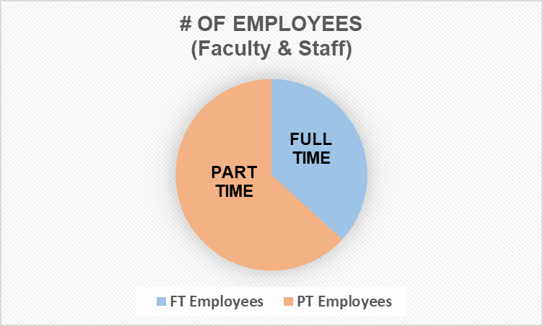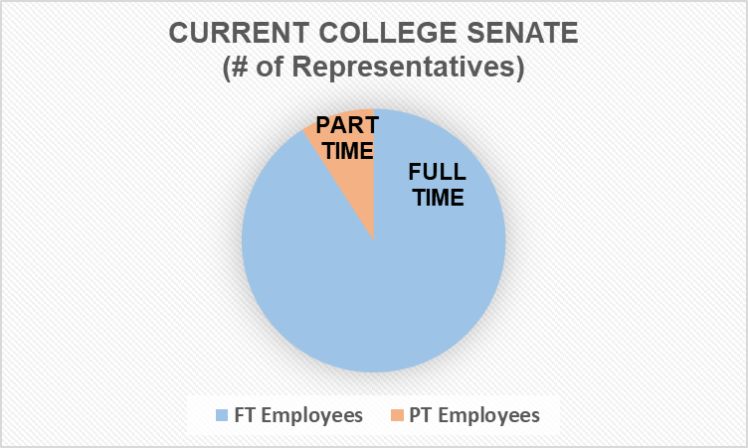

**Current Structure of Shared Governance Overall**

*These pie charts display the current overall shared governance structure at SF for employees and students (full-time faculty & staff, part-time faculty & staff, and students).*

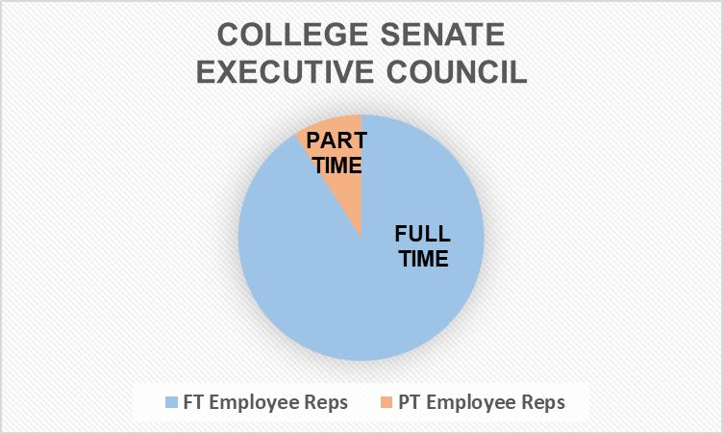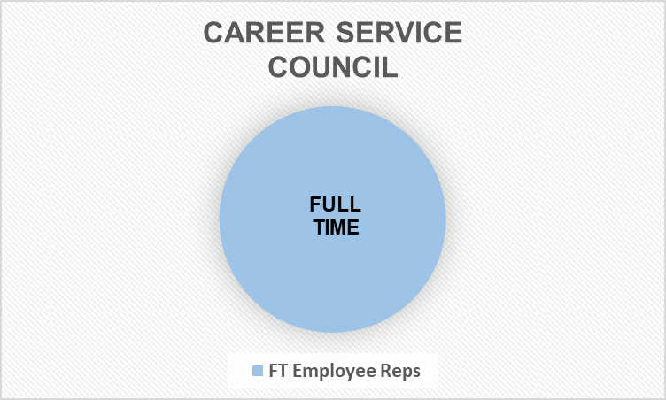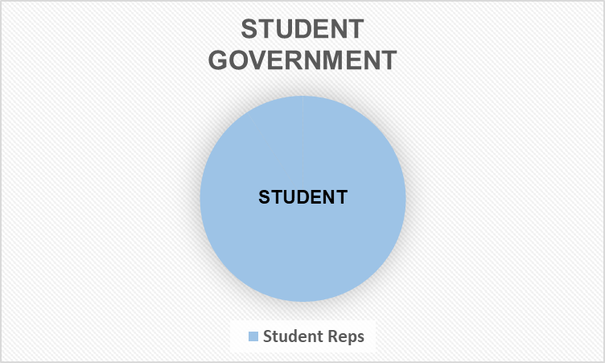

***Once you’ve looked at the four potential options for proposed changes below,***

***please select the box next to your preferred choice.***

**(“One person, one vote”)**

**PROPOSAL #1.** Proposal for equal voting rights within the College Senate structure

This proposal would amend the College Senate's Constitution and Bylaws to make all faculty and administrative and professional personnel full members, regardless of their status as full or part-time.

**College Senate Representation via # of Employees**

*These pie charts demonstrate how College Senate representation would change if Proposal #1 were enacted.*

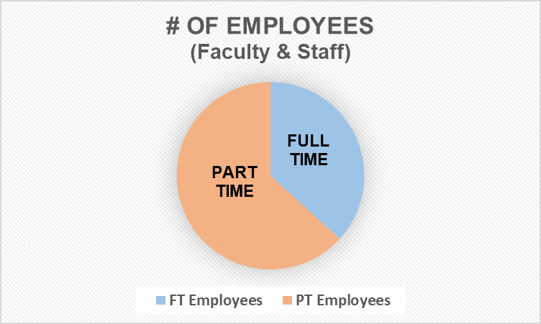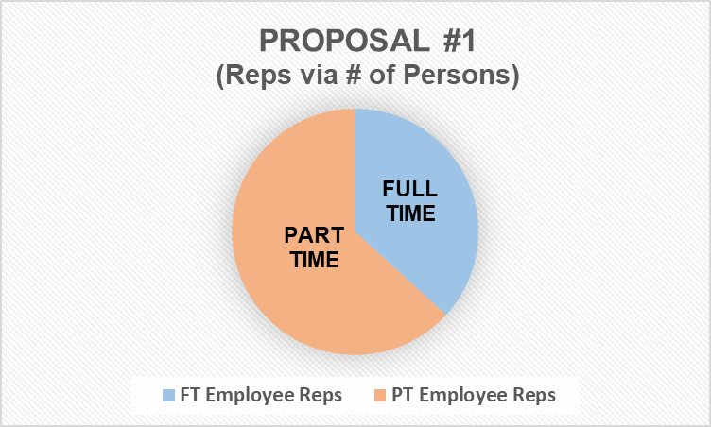

**Effect of Proposal #1 on Structure of Shared Governance Overall**

*These pie charts display how proportions for overall shared governance representation would change at SF if Proposal #1 were enacted*

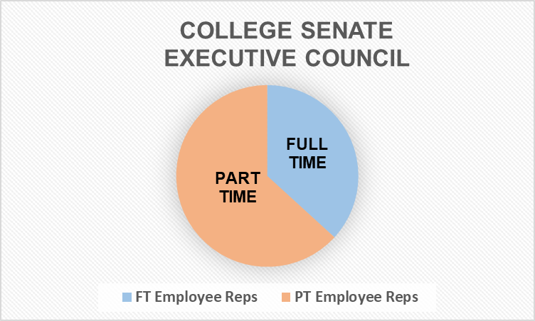

*.***Considerations**

* It would give adjuncts and part-time personnel full voting rights in selecting their representatives on the College Senate's Executive Council (EC) and ability to serve in any capacity, including full voting rights on Senate committees and EC.
* It would remove the current arrangement whereby three "Adjunct Representatives" share a constituency of several hundred employees while other EC representatives serve constituencies of approximately 8-22 members per rep.
* Enactment would require 2/3 approval of the College Senate.
* Since this proposal would add hundreds of new constituents to be represented in the Senate, it would likely require somewhat larger constituent groupings in order to maintain quorum in a reasonably-sized Senate. It would also require reapportionment and likely change the current weighting of constituent groups (i.e., some employee classifications and some departments would lose seats while others would gain seats).

**(“Separate but Equal”)**



**PROPOSAL #2**. Proposal for a separate part-time Senate

A College Rule be enacted that creates a shared governance body for part time employees that mirrors the functions, structure & standing of the College Senate as outlined in College Rule 2.4. https://www.sfcollege.edu/Assets/sf/rules/pdfs/Rule_2/2_4.pdf

**College Senate Representation via Two Separate Senate Bodies**

*These pie charts demonstrate how College Senate representation would change if Proposal #2 were enacted.*

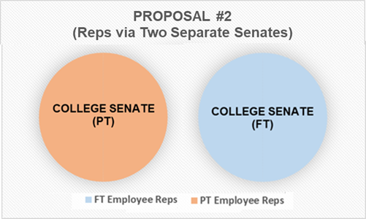

**Effect of Proposal #2 on Structure of Shared Governance Overall**

*These pie charts display how proportions for overall shared governance representation would change at SF if Proposal #2 were enacted.*

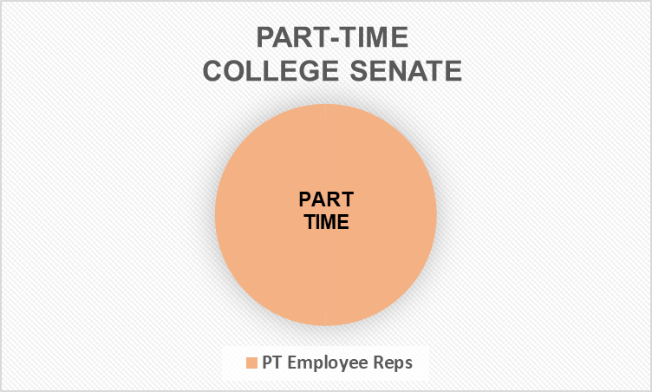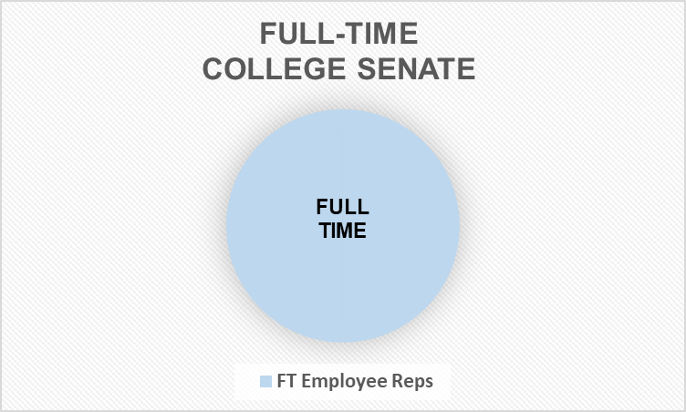

**Considerations**

* It would exist & operate independently of other College entities & make recommendations on College policy the same as College Senate, Career Service Council, and Student Government.
* It would give part-time employees an equal voice to full time faculty, technical professionals, & executive managerial employees.
* It would have no effect on the power of the College Senate & would not have to be approved by it.
* It would require Board of Trustees action to be formed or to be disbanded. (College Senate is in the same position)
* It would likely require voluntary time commitment of some part-time employees

**(“Hybrid Model”)**

**PROPOSAL #3.** Proposal for modified College Senate representation for part-time faculty and staff

This proposal would maintain the current constituency groupings in the College Senate but would add additional seats for representation of part-time faculty and staff.

**College Senate Representation via # of Hours Ratio**

*These pie charts demonstrate how College Senate representation would change if Proposal #3 were enacted.*

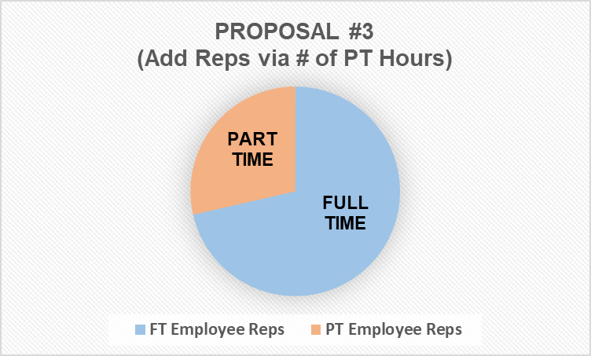

**Effect of Proposal #3 on Structure of Shared Governance Overall**

*These pie charts display how proportions for overall shared governance representation would change at SF if Proposal #3 were enacted.*

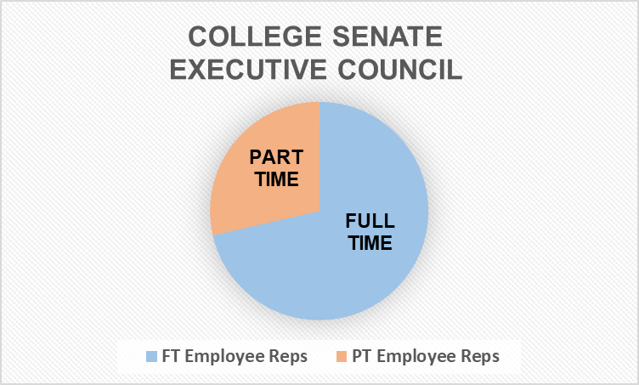

**Considerations**

* It would maintain the three at-large representatives for all part-time staff and faculty.
* In addition to these three at-large representatives, for departments which employ a significant number of part-time faculty and/or staff, additional part-time representatives will be assigned to the Senate. These representatives will represent the interests of both their home departments and shared interest groups (i.e., other part-time faculty and staff). These representatives will have full voting rights on Senate committees and the Executive Council.
* The number of additional representatives will be based upon the size and/or credit hour contribution of these part-time faculty and staff, resulting in something less than fully proportional representation but significantly more representation than these faculty and staff have currently.
* The number of additional representatives would be adjusted annually based upon the most recent employment data from the current fiscal year.
* This proposal would add new members to the Senate, likely requiring some reapportionment and changing somewhat the current weighting of constituent groups (i.e., some employee classifications and some departments would lose seats while others would gain seats).
* Enactment would require 2/3 approval of the College Senate.
* It would likely require voluntary time commitment of some part-time employees.

**(“Status Quo Option”)**

**PROPOSAL #4.** Proposal to make no changes to the current shared governance structure

This proposal would maintain the current constituency groupings in the College Senate. It would make no changes to the College Senate's Constitution and Bylaws or representative structure, and provide no additional seats for representation of part-time faculty or staff.

**College Senate Representation via No Changes**

*These pie charts demonstrate how College Senate representation would remain if no changes are enacted.*



**Effect of Proposal #4 on Structure of Shared Governance Overall**

*These pie charts display how proportions for overall shared governance representation would remain at SF if no changes are enacted.*



**Considerations**

* It would retain the three ‘at large’ adjunct representatives who currently serve a constituency of 750+ part-time faculty and staff. These three representatives would continue to be members of the College Senate, but no part-time employees would have formal voting power within Senate committees.
* Representatives for full-time faculty and staff would retain their constituencies of 8-22 members each, and each representative will have full voting power.
* No new members would be added to the Senate, and there would be no reapportionment or changes to the current weighting of constituent groups. It would have no effect on the power of the College Senate & would not have to be approved by it.
* Other than the three adjunct representatives, it would require no additional voluntary time commitment of part-time employees.