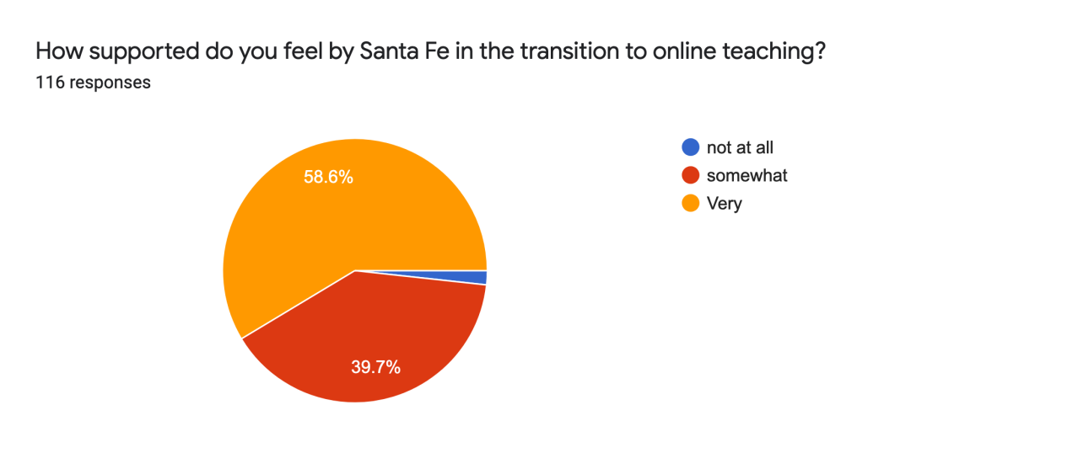
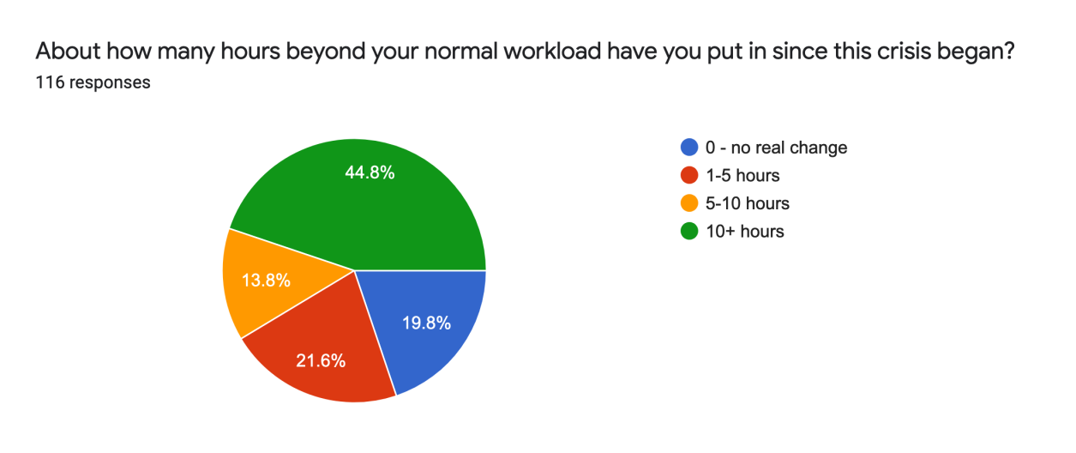
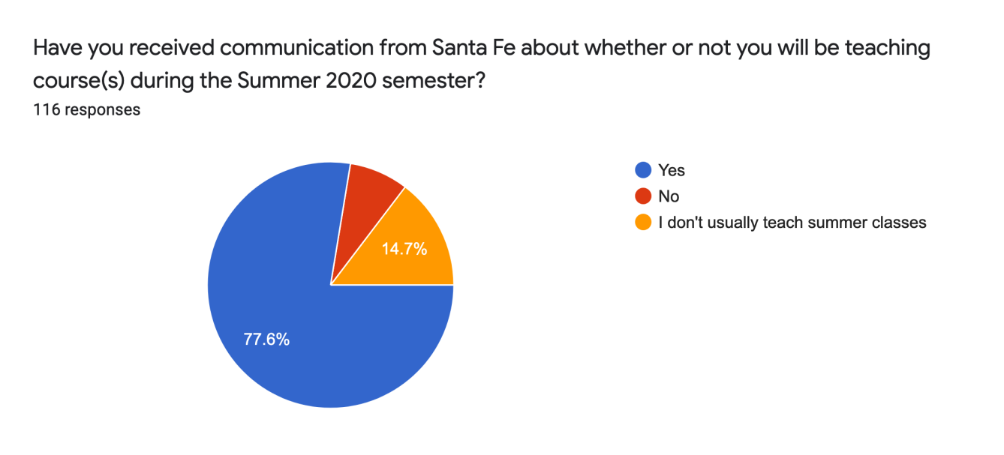
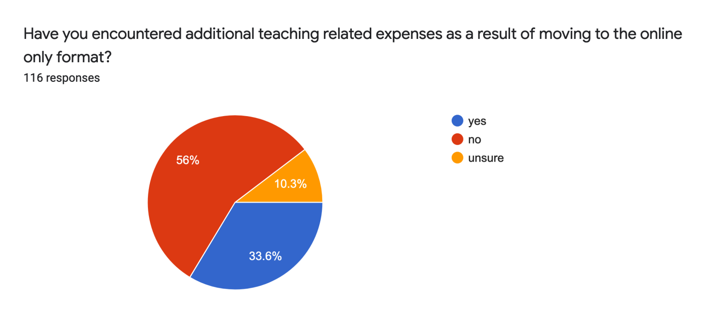
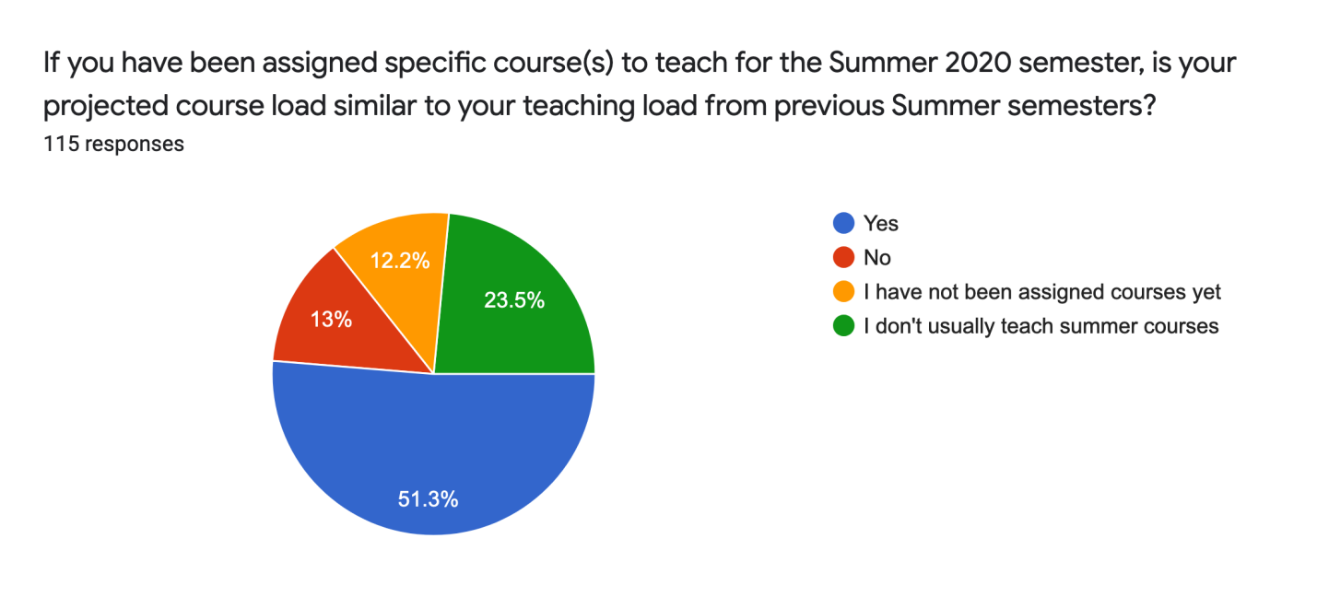
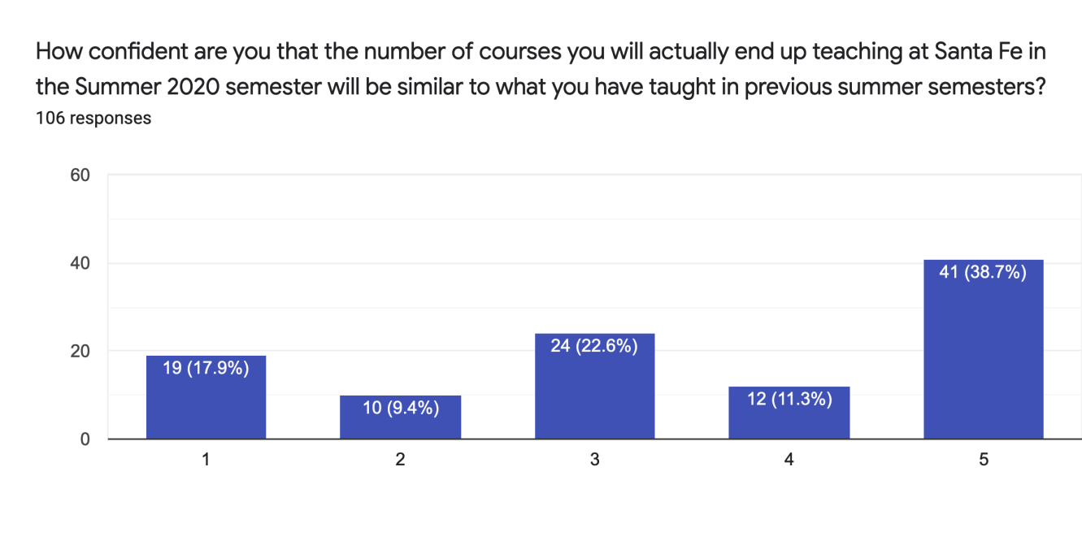
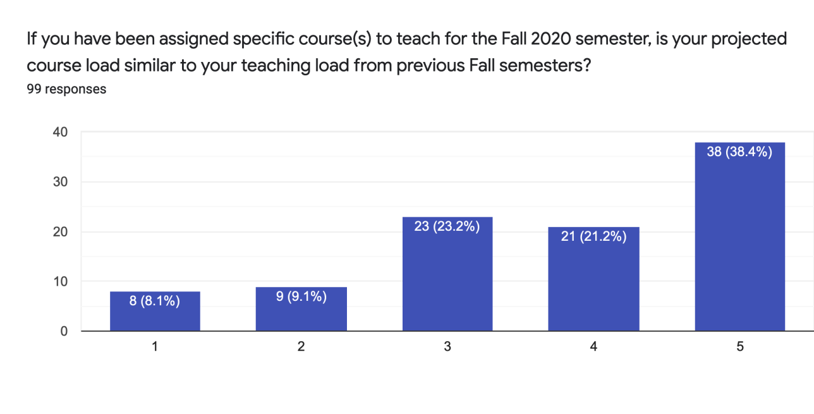
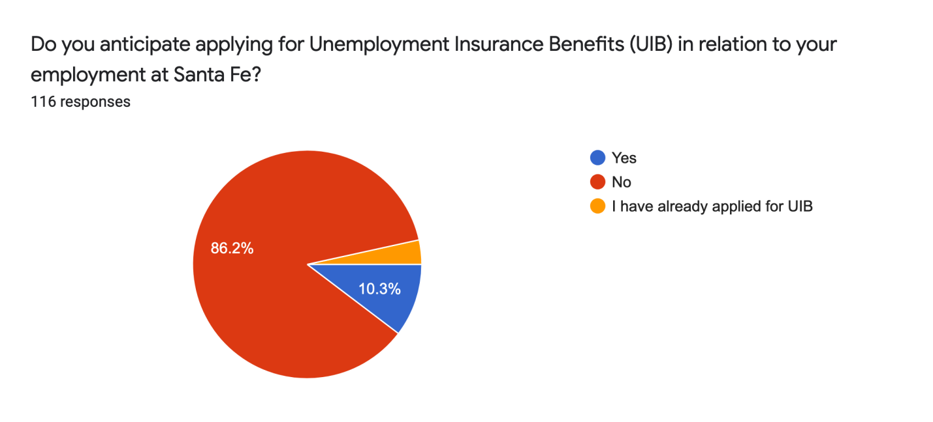
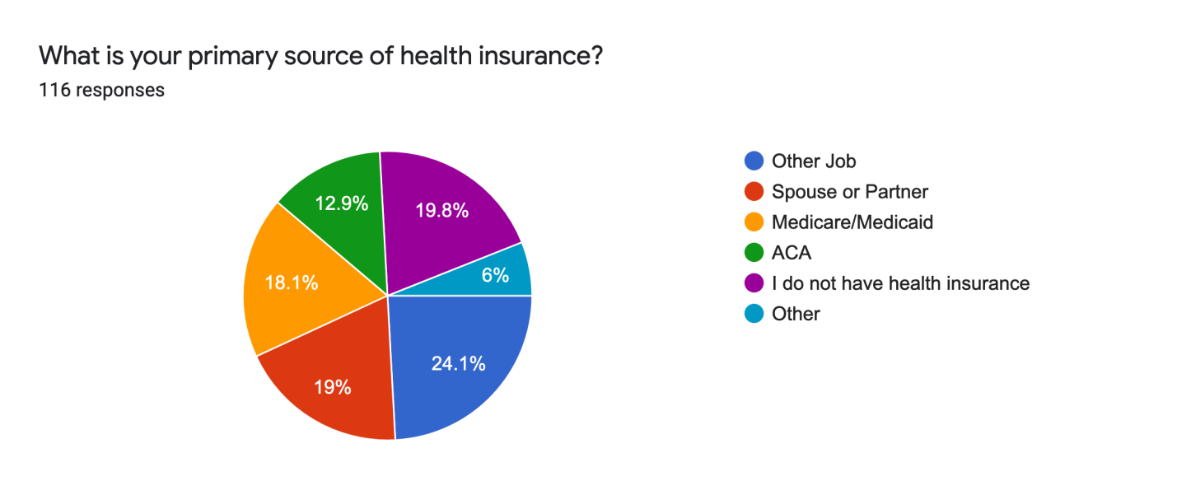
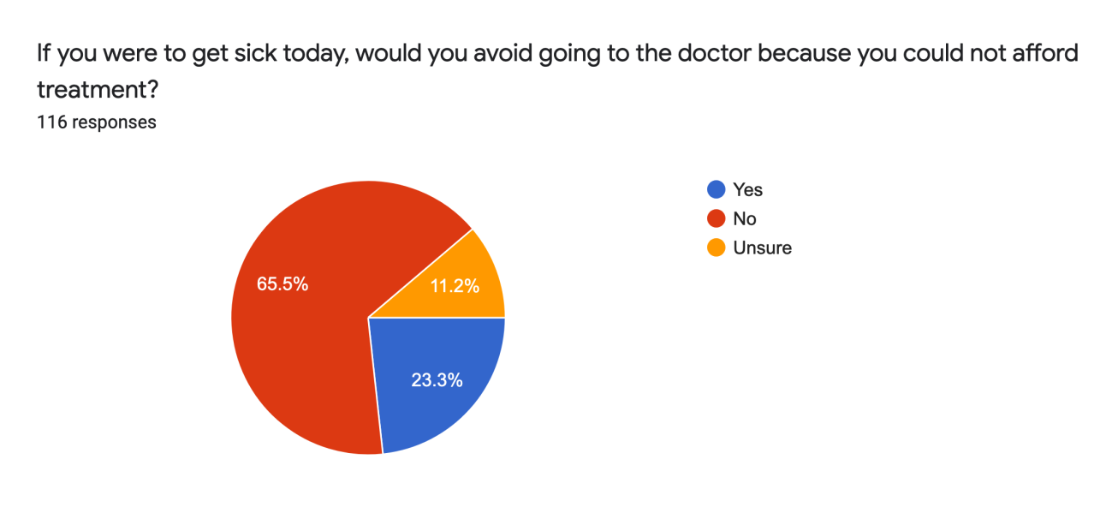
Please share any information Santa Fe has provided to you directly about whether or not you Summer 2020 or Fall 2020 courses will be impacted by the current crisis.

62 Responses

15 Report None at the time of the survey another significant amount reported that they were informed that their courses would be online in the summer.

I expect that the course I teach will be offered. Without the wet lab component, I do not think the course should be offered. The students miss out on all of the hands-on learning, which is their favorite part of the course.

My Summer B course was replaced with a Summer C online, but no information about fall being online or whether my satellite campus classes will still be on.

Where UF has declared early their Summer plans for online, SF has lagged behind, and the communication has been embedded abstractly in Presidential communications as well as long reply-all email threads where faculty have complicated and misinterpreted the transition to online.

There has been a complete lack of discussion about how those of us with young children suddenly at home might be impacted by all of this. It has been a real disappointment to feel that the college has ZERO understanding of the demands its parent teachers are facing.

I know that enrollment is very low in all 4 of my courses, so I am nervous that the courses might be cut. I don't know when that decision will be made, sometime in August I guess.

Santa Fe and the English department have been in touch about Summer A and B classes moving online.

My brick-and-mortar class will be online Summer A.

I teach lab courses, so if the College decides to do on-line teaching summer B those classes will be cancelled

I typically teach online. At this point, I have no summer classes scheduled and only 1 Fall section.

Same as always. Almost all my Summer courses are fully enrolled, and have been since they opened. Santa Fe does not usually jerk me around with my courses.

have to teach on-line where I have to pay for home internet (which I didn't have before)

I only have information about summer A Nothing about Summer B or Fall

I don’t teach summer but have not been told what the impact will be on fall.
Fall information is not yet known, BUT I BELIEVE it should also be online, for Flu+COVID19, I would feel MUCH safer, than on campus (if on campus, I may skip Fall)
my schedule is the same
.
I am already teaching my class online this semester, so there has been little impact to me.
None. The assumption being they will be in person classes.

I declined to teach this summer because I lack steady internet. "Live" online classes on zoom require solid internet. While I can build my canvas course content using my cellular hotspot, the cell signal does not support streaming platforms such as zoom. Given the lack of internet signal, I didn't see how online teaching could be viable this summer.

Enrollment is not looking good, I keep checking on my own. If I don't receive the course load I normally have, I will not be able to pay my bills and will lose my housing.

I have received everything I need.

none other than being assigned courses

No change - Use Zoom, fine with me

I have been asked to submit TAF and complete course information for summer and fall. I also reviewed the dept schedule which had my name on it. No formal agreement or tentative contract.
I have been told I Will not be needed summer semester and have been told nothing about fall.
I have not received any information about how the Fall 2020 courses might be impacted. urrently, I only have 1 Fall class and it is scheduled to for face-to-face and not online. I really hope it is not online!

Santafe has significantly reduced my classes since Dr Stephenson announced his retirement. For the 2020 year I have only had one spring. They canceled my summer and I am sure they will eliminate my one fall class. Last year I instructed 7 classes.

There has been no communication at all!!

I've been told about the impact for Summer A, and I know that Summer B and Fall are awaiting subsequent developments in the pandemic.

Summer course is online already, no impact. We had to cancel one lab course over summer that I was originally assigned.

We have been asked how confident we are that we could teach our classes if we had to go online-only partway through the Fall semester, as we did in Spring 2020. There is a great deal of redesign and rethinking going on. We are also asked to make explicit lists of concerns about sanitizing the physical environments we teach in, the space we have for social distancing, changes we must make to processes we teach and ways we interact with students. Some of these issues will affect whether our classes can be offered at all in the Fall semester.

The information posted on SF website

My courses were already 100% online. As long as my wife can keep her job, I can continue teaching as usual. The main impact on me is the impact on my students.

Summer will be impacted, but Fall we have not spoken about it yet.
Got to add an extra class online

Yes, I was told the enrolled might be less for Summer and some courses could be dropped.

A number of adjuncts have been reported hardships in meeting the challenges of teaching online. We would like to know more about your own experience - not just as it relates to teaching, but also as it relates to your personal situation overall during the COVID-19 crisis. What has this been like for you personally? What, if any, are your immediate/future concerns? If you are willing, please tell us more about what impact this crisis is having on you (family, financial, job security, emotional, etc.).

75 Responses

Financial and I wish I had health insurance!

requires a community of instructors, students and administrators; HonorLock usage represents business as usual; if you were a student, would you risk being in-class, with a 43% chance of failing, as the algebra students face; as an instructor over 60 years of age, would I risk in-class sessions - No, No, No.

I feel competent in my abilities to teach online, but the transition in this situation is difficult. I feel like I've had little support from the college in terms of resources, guidelines, other guidance, or even encouragement or appreciation for the extra work being put on adjuncts who are already underpaid. I am doing the best I can for my students because I care about them and their education. My own circumstances are not immediately dangerous but are not ideal. I can't afford to live alone, so I live with a roommate who is not following stay at home guidelines very strictly, so I feel more at risk of the virus. I used my stimulus money to buy a new laptop because mine is struggling with the extra work I'm putting on it with recording videos and holding meetings. I'm lucky to have been given more courses this summer than I usually get, and while I have four courses in the fall, I'm very scared about losing them, as I've been reading about adjuncts at other schools already losing their courses. I feel like the college isn't keeping us very up to date or being very transparent about how enrollment is being affected and what this might mean for the college and for adjuncts. I had been hoping to apply for FT teaching positions during this spring/summer for the fall, but a lot of those jobs have been taken down and hiring frozen at colleges across the country. So I don't have anything else right now but my adjunct work. I also fear getting sick because I can't afford health insurance. I already have medications I have to pay for out of pocket, and that's enough of a strain already on my income.

I have many years of teaching with an online format; I discovered that all of my courses moving forward will be designed, by me, for online format with equal application in physical classrooms. Personally, I have not experienced any negative issues with "stay at home" order. I feel well-rested, attended to my students more efficiently, individually, and was able to maintain a fantastic rapport with my students (all 120+)!

Financial hardship! I am so worried about what I will eat tomorrow or how I will pay the rend/bills, that I don't even care about the virus!

My biggest concern is my WiFi. What if it goes down during lecture (storm or lightening strike)? Where I live it can take up to 2-4 weeks to have internet repaired. Lots of what ifs types of questions... I know that WiFi will be made available in the Santa Fe parking lot, but my computer does not have a battery that will last 3 hours. Also, I do not want to teach in my vehicle - it is ridiculous. I am clearly stressed as evident by the emergence of shingles this week. Thankfully, I have insurance with my full-time employer. I wonder if the college system has even thought about staff susceptibility to stress related infections.

The only reason that I've been able to be marginally effective online is because I took the CODI course to learn Canvas, last year, and on my own time. We don't normally get paid for office hours, but most of us hold them anyway. But now, I feel considerably more stress because I'm constantly checking my email. I'm constantly checking or editing or clarifying on Canvas. I know that the academic job market is going to tank in the fall, and I need this work, but not having hope for anything full time in the future is demoralizing, at best.

The biggest worry I have is getting sick and not having health insurance. My work load has increased significantly but in no way will be compensated. I also have little to no security that I will have as many or any courses this summer or fall. It leaves me with no immediate or long term security.

I work in the Nursing Lab and do not want to work online, so if I have to create and teach some online classes, I will probably not work at all.

I teach 6-7 classes a semester. I personally got COVID-19 and went to the doctor (thanks to my UF insurance). Despite my weekly updates, students have been bewildered and confused because they have never taken online classes before. I get 50+ student emails a day, where I would get a fraction of that before. The Archer center has been the biggest obstacle. I have received communication that students do not have internet or access to the course, resulting in center directors speaking for students before they communicate with me. I don't mind giving incomplete grades and helping students through rough times, but if I can't make decisions on a case-by-case basis because someone who is not teaching my class has already excused a student who has been taught, in-person, the major assignments in my course, what autonomy do I have? Of course the communication has been abstract and probative, as in "Do you have students who are inactive in your classes?" I have been receiving emails from those students that have been declared too remote directly after the top-down excused communication. When they can read a prompt, access research and save it, and write an essay, do they need to be so handily excused without any contact with me? I have had none of these interference type of issues at UF.

I have to get a new computer .

I already taught online course, so the transition has been fine. I wish adjuncts who are extremely experienced with online instruction were given the opportunity to teach more credit hours, rather than forcing instructors who are not comfortable with it, during this time though.

I would REALLY have appreciated an additional week to convert the courses (like other nearby schools, mostly notably CF, handled it). Asking teachers to go online IMMEDIATELY, with no additional compensation for almost double the workload, when we ourselves are also trying to cope with the same pandemic-related stresses that our students are, is unreasonable and unjust.
It's more of a hardship for my students than me. I don't particularly enjoying teaching, by teleconference as you lose a lot of student interaction, but I'm able to do it.

No hardships on immediate family. Grown daughter now unemployed as result of pandemic.
I think the greatest impacts for me personally have been psychological and financial.

Psychological because I'm concerned about the pandemic and have no confidence at all in the current administration. So, I am not sure what guidelines to follow in order to stay safe and am concerned that many people I see in Gainesville aren't social distancing or wearing masks or other taking other protective measures. I feel unsafe and depressed much of the time. Financial because as an adjunct I have to work multiple part-time jobs. My other part-time work has dried up due to the crisis, so I'm struggling financially at the same time as trying to learn how to teach online and cope with the other stressors of the crisis.

Teaching experience: Normally, I give my final exams on paper in the classroom. Now I have to transfer the exam questions from paper to Canvas. Last week, it took me 16 hours to complete the lab final exam. I will spend this weekend doing the same thing for two more finals. I am concerned about working many additional hours in which I am not compensated for. Personal experience: I have to spend a lot more time online that I normally do. My family can only afford a Cox data plan that has 1024 GB monthly limit. If we exceed that limit, our internet service slows down. I've had to use Zoom a lot for virtual lectures for March and April. I've also had to look at a lot of videos to help me prepare for using Zoom, Honorlock, and teaching labs online during the summer. I exceeded our data plan for April and internet service has been slow. In addition, I spend a lot of time at my dining room table preparing class materials on my laptop. This includes working at night. I haven't received my GRU bill yet, but am concerned that it will be higher than normal because of this. My laptop is 7 years old and when I use Zoom, it heats up a lot. I'm concerned that my laptop will break down and I'll have to get a newer one sooner than I would have had to otherwise. I'm very grateful that I have a job. Yet, I feel like Santa Fe College is taking advantage of me, even more so than during normal times. I feel used. * A note about this question above "Have you encountered additional teaching related expenses as a result of moving to the online only format?" There should be an option to select "not yet". I would have chosen that instead of "unsure". I haven't had to pay for anything yet, but almost certainly will.
The teaching load seemed to double going online. Emotionally that's made it challenging.
I have learned more computer based technology than I ever expected to, but that has been a positive experience. The IT depeartment has provided wonderful help with both Zoom and Canvas related issues. My biggest concern is returning to the classrooom too soon.

I had been using Canvas all along. I had previous Zoom experience, but not as instructor. There were a few glitches where I learned the limitation of Zoom and occasionally had to re-record a lesson. I really miss the great doc cam in my classroom on campus, but my iPad is "good enough" so that the students hear my voice and see me write on the paper. The extra time I have spent is creating multiple question sets for a test along with the number of hours I stayed online trying to get everyone finished. For the most part my students have followed instructions well. I work because I want to, not because I need the money (though it came in handy when my daughter became unemployed due to COVID). I'm not returning in the Fall because I have other obligations.

Although the college offered to lend computers, I do have my own laptop, which is incurring lots of wear and tear. Otherwise, I feel lucky.

It is literally DOUBLE the work to teach online. I am lucky that I am part-time and paid hourly, so I am being compensated for the extra work. However, adjunct instructors who are paid via stipend are being robbed/abused right now since they are already underpaid. Also, there has been a complete lack of discussion about how those of us with young children suddenly at home might be impacted by all of this. It has been a real disappointment to feel that the college has ZERO understanding of the demands its parent teachers are facing.

I have spent a lot of time training on Canvas and Zoom. I am not entirely competent on either but have been getting by. I know I will need a lot of additional training. The canvas support videos just don't work for me. I also am spending a lot of money on paper and ink for my printer/scanner and have to purchase a document camera to use with zoom, so I am out about $250.00

I previously completed the on-line instruction course offered by SFC and have been using on-line components with my HS and College students already so the transition has been easy for me. I know that is not the norm but I was accidentally ready for this transition. I do miss in person lectures though. My future concern is the same as always, job security. Will I be needed next semester? So far I've had a use but that may end at any time with almost no warning.
The transition to online has been actually pretty easy for me, as I've taught online and hybrid courses in the past and have good knowledge of Canvas; I also am a FT online teacher as my FT job. However, the transition to online has significantly increased my workload. When in the classroom, students often engaged in activities where I was able to observe and monitor their learning and there weren't specific graded assignments. With the transition to online, there has been both more prep work and more to grade, and it has been very challenging to keep up with in conjunction with my FT teaching job AND having my kid doing school from home with me FT as well. Honestly, if the pandemic leads to school being out once August rolls around, I'm not sure I can sustain adjuncting as well, especially as I'm slated to have TWO courses in the fall (and have only one now), especially not for the pay.

The transition to online teaching was quite smooth, my current/future big concerns are financial (lack of job security, health insurance, benefits, so on). There is a huge gap in payments/benefits between a full time and a part time, although we are required/expected to work as much as a full time (except holding fewer office hours) to meet/exceed student expectations.

It feels terribly isolating even though I ZOOM twice a week with my students and periodically with my collegues. But there is something about human to human contact that cannot be replaced by the Virtual environment. Personally, although I am extremely stable during this time, I have had to put "things" in place and order. When I view things as happening in a chaotic worldly manner, things get sideways very quickly for me. But when I turn my face toward Jesus, and assert that nothing is out of control, that I am not experiencing some entropic event, my life becomes extremely stable. Yes, I have been emotionally overwhelmed, especially in the beginning which caused me to go into command mode for me and my family. Responding by doing things such as abbreviating news times down to about 2 times a day most especially when broadcasting in common places at home such as the living room, increasing conversations about the Sovereignty of God and saying comforting words such as, "Nothing is out of control", and encouraging expression and conversations about how things are impacting my two adult children who had JUST moved back in to the house after their graduations. One from SF and one from UF. My immediate concerns which are the same as future concerns is how long will this continue? How long will I be teaching virtually? No one has a crystal ball and can predict, so I turn from that question to another, "What are you doing God? And how should I respond in experiencing You?" I have concerns for my students. There are a few that do not have proper devices or stable Internet and their choices are limited in gathering these resources. 1/2 of my students did not make the March 16th transition. I was gaining momentum in increasing the class size up to when we had to go virtual and that is when I lost literally 50% of enrollment despite numerous attempts to contact and troubleshoot. One thing that would be helpful is to open up the parameters for laptop rentals. Our students are not eligible to receive a laptop loan.

The most difficult part, for me, has been seeing the very distinct class and race line as determined by which students are able to "keep up" with online learning. This, of course, denotes an accessibility issue and much deeper- seeded societal issues at large. There is still something very difficult about watching this inequality play out in real time, and being all but helpless to do anything about it. Nearly all of my students who were already struggling to keep up (with both difficult subject matter and out of class assignments) with the benefit of in-class meetings and internet accessibility on campus have dropped far below their potential. It feels as if many of the benefits of teaching (connective, cognitive student learning) pale in comparison to the difficulties (so many emails. so many student questions.) as magnified by this crisis. The vast majority of my time and heartspace is taken up by the work associated with teaching my courseload, and so the impact that the crisis has had on my personal life is inextricably linked with the impact this has had on my classes.

To start, I am grateful to be employed right now. That said, teaching online has been challenging. My husband, a UF professor; my daughter, a high school student, and I, an ESOL specialist teaching 3 low English proficiency ONLINE classes, are vying for the same space and computer resources. Consequently, I had to borrow a laptop from the college to do my work, and my family has had to rearrange our living space and stagger our (online) classtime to work within our noise and bandwidth limits. I am spending many more hours sitting than I ever did as I'm holed up in a closed room developing materials and conducting online classes.

I am having a difficult time adjusting due to my personal preference of working with students in person and disliking online instruction. I have never even taken a class online. I look forward to trying. I have an intense dislike of video mediums such as Zoom, however, and this has a very negative effect upon my life and ability to work. I also do not have WiFi as I live in the country and in the wetlands and it is not available where I live. I use a Hotspot but sometimes it does not work. I tried to do a Zoom meeting at the Micanopy library but it kept going in and out and said "low bandwidth". In addition to this, I detest doing Zoom or anything of this sort. I know I am not the only one, and I suspect it is why a number of students have dropped off as well. Of course the world crisis is an major issue as well, but I think there ought to be more options for those of us who do not feel comfortable to work in this capacity for a number of various reasons. I am also not able to work as many hours because of this which is frustrating. My boss is kind and attempting to be flexible, however.

I'm retired and teaching part time, so I'm in a risk group and even though the college and my department have been very supportive, I will need to make a decision about continuing teaching. It is difficult to find qualified teachers for the classes I teach, and I enjoy teaching. A specific on-line teaching difficulty for me is that I live in an area where I can't get fast internet. I have the fastest possible DSL, but the quality of the zoom recordings is not good.

While I typically teach online, the addition of my "day job" being online and my kids being home and online has made it hard to keep up. I am concerned about the lack of summer sections and reduced fall sections. I understand that full time faculty have to maintain load, but I do depend on the income.

I work 3 jobs to be able to afford rent and private health insurance. I work about 65 hours/week. This is no way to live, this grind. I've been teaching 20 years and it's shameful that I'm a heartbeat from poverty all the time. Covid19 has brought that home. Santa Fe should be ashamed of itself, letting us toil like this on the edge of economic disaster while useless Administration people get fat salaries *and* benefits.

There should have been a week of suspension of classes to transit to online

Since I only teach online, the impact on me has not been great. However, I will be assigned face-to-face classes using Zoom and this will be new to me. Also, since I have so much experience with online classes, I have also spent a lot of my time helping others -- this is beyond my normal workload.

I don't like having to teach an online class. I send out lots of correspondences to my students but I never hear anything back from them. I don't feel like I am in touch with my students at all. I can't get my students to respond to me. It seems like all they do is study on their own and take the exams, they haven't been participating in discussions or office hours or online meetings. It makes me feel like I'm a pretty horrible professor, to be honest.

The increased workload at adjunct pay, not to mention the heightened job insecurity, is extremely stressful. I have no savings to fall back on.

I have to pay for the additional internet charges. I have equipment borrowed from the college but fear they may take it back at any time. I was teaching at centers making additional travel money which has stopped.

I have taught online in the past and I have taught brick and morter in the past. I enjoy teaching online, but I found it incredibly difficult to transition mid semester from a brick and morter classroom to an online class. It wasnt just redoing course content. The students had an incredibly difficult time adjusting, and for a while I thought we were going to lose a lot of them. Thankfully we were able to re engage all but 1 student, .but it did require a lot of adjustments. I have found the online support and encouragement of the Santa Fe administration to be incredible and truly supportive during this time. I really appreciate the webinars and online support.

I feel that some students will struggle with online only but I do think the college has provided a lot of resources and training to help bridge that gap.

Keeping students motivated and engaged online was challenging. When it comes to critiquing video productions, being in the classroom as group is extremely important. Zoom screen sharing was not great, it lags and isn't visually the best quality. As an adjunct, I was not allowed to take home my work computer so my laptop is not the best for working from home and using Zoom. Not to mention access to campus labs is essential for students. In addition, there is just something that is lost when it comes to comradery with an online classroom, it's just the nature of the beast. Finally, students who enroll in our Digital Media Production courses do not want or expect to be online. They want and expect access to the thousands of dollars of equipment we utilize in the classroom. Also, I have already had the majority of my incoming Fall BAS first year students say they will take the semester off if it is online. I do not have access to my BAS second year students so I have no idea what they are planning for fall. Needless to say, this means it is possible that I will not have a class and will not get paid in fall.

I am thankful to have gotten paychecks for the spring semester. I'm disappointed my credits will be cut (if I have any for summer). I feel like the leaders in my department have done the best they can to support me. I was afraid because I am an adjunct I would be on the short list to be cut and accepted a part time job outside of education to keep a second income for my household. I am glad now that I took those steps. I am concerned for coworkers who will not be able to find jobs elsewhere, especially since most people have not seen any income from unemployment in Florida. My spouse was the primary earner for our family but even his hours are being cut.

Tremendous number of extra work hours in migrating blended to online, grading is MUCH more laborious, as was entering exams into CANVAS. Twice the work, a quarter the satisfaction, sadly. But my chair D. Tegeder has been great. Also am taking ZOOM class, in prep for fall, will be buying some hardware for that too.

My most immediate concern is lost income because I can no longer supplement with substitute pay. There is no need for substitutes if there are no live classes.

i have no concerns, teaching online should be expected - we should be flexible. Even if teachers teach in person they should have on-line assignments in Canvas

Emotional toll is immense. I feel personally bad if students are having a hard time transition but they are still not performing sufficiently. I understand they too are under enormous pressure, but I can't providing passing grades for subpar work - Covid or not. Then I know I'm causing them more stress during this time period. Also, I'm already concerned about 2nd wave in the Fall and in person classes.

Switching to online has not been a problem except for the fact that my class is one that requires a piano or keyboard. This is not a piece of equipment that most people have. It would be helpful to have keyboard that could be checked out by students, but I know that isn't exactly cost effective. I've already lost one class this summer because of this and may lose one in the fall if it stays as it is now.

I will not have my other job over the summer, so I will only have this SF adjunct position, and this is a financial concern.

I lost my other source of income due to the crisis and am still waiting on benefits.

Because I live in a rural area of Alachua County that lacks broadband coverage, I have been relying on using my cell phone as a hot spot. It has created a lot of challenges: I have gone through a huge amount of data while switching to online instruction, at personal cost to me. Because of the expectations to include zoom meetings and other streaming during online "live" classes, I have been driving to SF campus to access the parking lot wifi and teaching from the inside of my truck, which is not an ideal pedagogical environment. Because I do not have a reliable internet connection, I am not teaching this summer term. It's almost impossible to teach online "live" classes if one does not have good, reliable internet. It breaks my heart to leave my students and teaching, but given the current situation I don't see any viable options at this time. I hope I am able to return to teaching at SF in the fall. I love teaching at SF and am really going to miss it this summer. We talk about the "digital divide" affecting students, and in my situation, it impacts teachers, too.

I teach labs mostly so while I was able to work with my director to finish the semester with an alternate assignment, there is no further guarantee for me for summer classes, which is when i generally make the most money.

It's stressful for my family members. They have to remember when I am having online classes and remember to be quiet or not to enter my home office.

Spending more money on food, electric bills, internet upgrades, phone upgrades, job security
This crisis is having a huge impact on my finances and well-being. Given adjuncts have zero job security, if our classes don't fill, we don't get paid. If I don't get paid, I'll be homeless. A very sad reality for many adjuncts where teaching is their primary income. If I were to get this virus, I have no health insurance to see a doctor. Let's not talk about a potential hospitalization. While the college has bent over backwards for the students (and we should) I haven't seen any communication in support of what they are planning to do for us adjuncts which, quite frankly, upsets me a great deal. It is very disheartening and makes me feel unappreciated as an employee.
Mine has been good. Just some things are easier to teach in person.

Moving to an entirely online format while also having to navigate childcare and monitoring their online learning (since school is now online for them as well); not having access to childcare and other assistance has been very taxing

There were two issues, I had to learn how to use Zoom and Canvas and got my students on board, but it all worked out well by the time we finished our Spring semester. The second issue was creating Canvas homework and then correcting it. That took a long time and the students did not get the feedback until the end of the semester.

I feel like I am doing more work planning than the hours I am allotted to get paid for, resources like equipment I could use on campus is not really available to me remotely so extra costs are involved for me.

I have been teaching online for almost a decade. This has not been an issue for me. Thankfully I was prepared for this particular issue to come up. However I do understand this has been tough on the traditional professors and sympathize.

I said I could teach in the summer but was never contacted about it and then saw all the empty sections were given to others. Even though I am not as tied to the adjunct salary as other adjuncts, the stress of not knowing or getting a section at the last minute is not appropriate, especially since students pay the same no matter who is teaching their course and the students deserve better. I was asked to use a opensource textbook since it was free to the students instead of the one I have used before which was about $25. I discovered the testbank was available online about mid-way through the semester so all the quizzes I uploaded as a part of the package were compromised. This has been very stressful since I have never encountered this before. I did not have enough time to vet the instructional materials before the class started. I am not sure if my one class will "make" in the fall and whether or not to invest any time in re-creating quizzes for nothing.

There is no statement of what technology and skills are needed to teach online at SF. As an adjunct we are required to have our own internet connection, computer, browser, security software, scanner, printer, office apps and mobile phones. You must have these to keep up with college administration email and course delivery. Full time staff have these provided by the college. The training this semester has been great but why didn't we get this sooner? I am concerned over the lack of consistency and course quality. No one has asked to see what I am doing well or struggling with as an adjunct. Big positive for adjuncts is more communication and inclusion in meetings than ever before. Hope this continues after the crisis.

My husband makes good money, we will be fine. This may precipitate my retirement.

I haven't really had a hardship for teaching online. I have spent more time learning how to put tests/quizzes on Canvas. I am concerned for my students and having to use Honorlock for their Final Exam.

The increased job insecurity is very stressful - and the fear of getting sick while having no health insurance doubly is so.

I've taught online for years at SFC, and I took the CODI course before it was required. Much of my physical classes had a significant use of Canvas, and I already had an online class going this spring, so the transition was easy for me.

I don't have any hardships to report and work remotely under my current position already. This crisis has not impacted me.

Trying to teach kids at home, keep them busy and OFF screens as much as possible while teaching/taking care of classes, etc. My husband is working from home as well. It has been a challenge but SF and Dr. Tegeder, et al have been totally wonderful, supportive, offered insight and help all the way along. I have been 100% supported and taken care of and have felt it! :) We live on my husbands salary and he still has his job so ok there. Further we're actually saving money on daycare and our jobs. No need to worry here.

My studio art classes are not being offered this summer, so that income is gone. The retail galleries where I show work are closed (or online only, which would take a huge amount of effort to make work for me). There will be no GFAA artists' studio tour this summer, which was previously a survival lifeline. Some of these venues may not reopen at the end of this pandemic. I may have to seriously pursue completely different lines of work, as yet undetermined.
deep financial impact, increased job insecurity feeling

So far, I'm doing well. My wife earns most of the money in the household; I teach what would be considered "full-time" some semesters (three preps, four sections) but even if I were teaching at a second school I wouldn't be earning close to "full-time" money. But so long as she can keep working, we'll be fine financially. My daughter is stressed, and I have taken to babysitting my grandson five days a week to help her. My social life has shrunk to pretty much nothing, but I'm an introvert and I'm not noticing any feelings of isolation: I have my immediate family. I spend more time supporting others emotionally, and trying to help students online as best I can. And I'm going to need a second job over the summer if I don't get another course.

I have been teaching advanced ESOL students. They have been writing a lot and I have been printing all their work to correct it by hand as I find the Canvas/SpeedGrader extremely cumbersome and I do not have a scanner to send their corrected work back to them. I have had to buy extra paper, ink, and envelopes to send the work back to the students. Teaching online has taken many more hours of preparation and correction. I am very lucky that I am safe at home and I have a support system of neighbors and friends and we are in contact almost daily.
Honestly it's less work in total I save 40 minutes a day driving to and from campus and often I'm able to lecture for only 20-30 minutes and show recorded material between different class sections. I'm more comfortable teaching online and from a professional standpoint this has affected me positively, although being stuck inside all day is not the best for my mental health.
The college gave me a computer and has provided extraordinary training for my classes. I have enjoyed meeting the challenges with the help of Bill Stephenson, Tim Fojtik, Canvas and Academic Technology Help Desk, and students' willingness to attend Zoom meetings and continue with their assignments via Canvas email. I have enjoyed President Broadie's High Fives and encouraging addresses and Ed Bonahue's Wednesday updates. My present concern is working out my schedule for Summer A teaching and how to change assignments to better fit the online situation. Otherwise, I prefer on campus teaching to this one, but I am in good health and attitude.

My students have gone totally MIA. I feel like I am just going through the motions with no real outcomes.

Finally, what support would you like to have from the college during (and after) this crisis? Is there something you need that the college might consider providing during this crisis that is not already being addressed?

69 Responses

Give adjuncts benefits already will ya!!!???

yes, taking 20% from admin and full timers to pay us!!!!!!! why are they funded when classes are reduced or not offered; also, why are they alone making life and death decisions for our students and for our part-timers

I think adjuncts should be awarded some kind of bonus for the extra work being conducted or need-based grants if they lose courses, particularly if it's because those courses are given to full-time faculty rather than just cut entirely. I think some consideration toward sick leave and health benefits needs to become a part of college budget considerations because adjuncts are the backbone of Santa Fe labor and if we go back to face-to-face courses in the fall, we are placed not just in medical risk but also financial risk.

It is important to stay connected with faculty, staff, general personnel, and students regardless of pandemic; using texting, zoom, email, and old fashioned telephone calling (when necessary) is a great way to accomplish this. It is also important to enjoy hobbies, get a little sunshine, and develop oneself.

If we do the same work as full time professors, we must have the same pay and benefits! Everything else is just empty words. The concept of part time professor should not even exist.
My work load has greatly increased due to this pandemic and switching from classroom to on-line teaching or hybrid or whatever we are calling it now. My department has been great in providing support for lab instruction, but I am not sure what the expectations will be for summer. Even so, I am unhappy with the compensation, but I feel obligated to teach since it is late in the semester to change my mind. I am riding the fence on fall, and it is likely that I will take that semester off especially if it is on-line or hybrid teaching.

A guarantee of some income for classes on hold/canceled at the last minute, serious consideration of paying into Social Security for adjuncts.

Increased pay. Access to more technology. Healthcare. Hiring more full time faculty. Allowing all teachers to teach online now without taking the Santa Fe course.

Paying instructors more for online instruction. Infrastructure for students. Offering TAs.

Adjunct should be compensated for extra time finishing the semester

Back pay for additional hours worked.

Feel fully supported by College in many ways. (I am full time staff & adjunct so my perspectives may be very different.)

Health insurance for adjuncts. Also, more support for adult ed students.

I would like reasonable financial compensation for all of the extra time that I have worked. I would also like compensation for any amount in my GRU bill than is more than what my family normally uses. I would also like to receive compensation such that I can get a Cox internet data plan that will allow me to prepare for my classes, make videos, have virtual lectures and virtual office hours.

Thank you for giving adjuncts a chance to report how this challenge is affecting us.

I would like some assurance that, if I become ill over the summer and have not recuperated by the beginning of fall class, I would not lose my job.

The college has provided excellent support. Nothing more is needed right now.

Not really. I'm pretty self-sufficient.

My chair has been proactive in calling me and all other members of this large department. I feel that I could ask him for help or interevention during this situation, if need be. Thank you for your concern and inquiry.

Yes, provide free access to printers, wifi, and computers for all instructors, regardless of full-time status. Also, please understand that instructors with children suddenly at home will struggle with synchronous classes. Requiring all of us to use live Zoom classes when we are at home in varying living arrangements is ridiculous. Also, I would like to add that the online and in-person Zoom and Canvas trainings were excellent and timely. Thank you for providing those.

More full time positions for adjuncts

I don't know if this is specific to the college or just my department, but I've frequently felt a little lost. I'm thankful I have a friend more familiar with practices and procedures, because I have at times felt uncertain about what I'm supposed to do.

Equal payment and benefits as a full time, if we do the same work as a full time per course.

Yes, please reconsider allowing non degree seeking students for a laptop loan.
My department chair and colleagues (Humanities and Foreign Languages), as well as the canvas support team, have been unrelentingly helpful during this time.

Job security

Better compensation. It's almost impossible to find a full-time job that can accommodate the 75-minute teaching interval and sustain oneself. I have to work an overnight job just so I can afford rent, utilities, and my car because there are no other day jobs that will make way for me to also teach during the day.

Health insurance would be very nice!

The IT department and Andy Sheppard have been outstanding.

My hope is that, when this is over, we have a chance to reflect on the overall picture of what worked and what didn't.

They need to pay us a living wage. They need to give us health insurance, or at least give us the option to buy reduced-cost insurance. They need to have better mental health support for us (not just that bs EAP stuff). They need to find a way to give us sick leave or paid vacation time. We have earned it. The college functions *because of us*.

Yes, getting me a computer that I choose. I constantly worry about what would happen if my computer broke! Because of the courses I teach (Computer Programming) I cannot use the generic laptops available from the college because I need to add many programs that those computers are not set up to (a) allow me to add and (b) handle.

This was my first semester teaching and it was a pretty terrible way for it to end, but that was not in my control nor within Santa Fe's.

Of course, adequate pay, social security, and health insurance. Aside from these... Switching to online classes mid-semester was a challenge for everyone, and I am impressed with how the Santa Fe has handled this crisis so far. BUT I am concerned that we will reopen too soon (Fall 2020) - and end up having to shift back to online mid-semester again during a second wave. I think it makes more sense to stay online for Fall 2020 - which lets teachers set their courses up appropriately in the first place - and will prevent the scramble that teachers and students alike will have to go through (again) come November(ish).

They should pay for home internet if we are required to use. My time spent on these classes has gone up to 8-10 hours a day. I have 4 sections. It is assumed that I be at the beck and call of students 24/7 and give "breaks" to students about their work.

possibly access to webcams would be a plus.

The college HAS to start paying into social security and HAS to find a way for adjuncts to get health care benefits from the college since we make up the majority of the teaching staff. Also, they need to find more full-time positions. Adding three this year is a step in the right direction but more is needed. Take the Digital Media BAS degree, there is only ONE full-time faculty educator for this program. So that means the weight of essential courses within the Bachelor's degree is on adjuncts' shoulders, that doesn't make any logical sense. This is the only 4-year degree in the Fine Arts Department, and one of 9 Bachelor's degrees within in the college. I think more attention should be given to our program especially with UF deciding to eliminate their Cinematic Fine Arts program. We are filling a void/need in the area and with more support, our program will only get better and draw more attention, hence bring in more students.
Clear direction and support for what to do now, created specifically for adjuncts/tempforce who may not have an income in the coming weeks. I do feel like we are in the same storm, but a different boat than the full time faculty.

none, i thought they did a good job

Financial assurance that regardless of Covid they will protect their employees, esp. those that are not salaried.

HEALTH INSURANCE!!!!!!!!

Better pay for adjuncts in general.

Payed leave, and adjunct salary increase

It would be nice to have a small stipend to cover some of the unexpected expenses involved with setting up a home office to teach from home

After this hopefully consider moving part time positions to full time(if they would be able to) this would allow more benefits for their family. More hours would help at this time. Open benefits for p/t staff that have students graduating from high school and will be attending santa fe. Times have become more difficult. Offices that are shared, each employee should have their own office or a divider. Staff should not have to share restrooms with students. They should also be cleaned during the day and smell fresh in the mornings, and have deodorizers.

Emergency funding for adjuncts. We should still be paid our normal salary even if classes get dropped, the same as full-time employees do. This is a global crisis and that is the very least the college can do for us. Many companies are still paying their employees their salaries. The college receives plenty of government funding and should use it to help adjuncts in addition to their students. After all, we are the ones teaching! Going forward, we need access to health insurance.

This semester required that I spend nearly double the amount of time that I had in previous semesters. This was a result of not only having to convert the classes to online, but in navigating administrative and testing issues, and spending a great deal of time working with students who are seriously struggling. Adjunct pay is already meager at best; I wish the College would consider some type of stipend to adjuncts, to compensate us for the significant extra demands placed on us this semester.
To give us credit for all the extra hours we put in to create lessons and then correct homework.
Pay is really the issue. I am paid almost twice as much for far less work at other schools. I have stuck with SFC out of loyalty.

Overall, the campus community is working very hard to help everyone. I am pleased to see how the adjunct issues are receiving more visibility through the College Senate. Job security is at an all-time high and there is significant disparity in those who get four classes every semester and those who are "last on the list" to get a section to teach. How can we make these decisions a bit more transparent?

I would like the college to continue Zoom so all can attend staff meetings. I would like a tentative contract with technology requirements (internet service, computer, apps, browser, etc) and skills I need to have to effectively teach at SF.

Just direction about whether there will be on campus classes in the fall.

I don't think that I'll need further support from the college.

Obviously, I would like to see the college provide support by way of adequate pay, job security, and health insurance, plus reimbursement for our additional time and expenses resulting from the move to online classes. I would also like some clarity from the college regarding how the CARES Act (and its additional protections) might apply to adjuncts filing for unemployment benefits. Beyond those, I would like to the college to consider remaining online for the Fall 2020 semester. Otherwise we will likely be forced to switch from in-person classes to online classes mid-semester AGAIN when the second COVID-19 wave strikes (November-ish). I prefer teaching in-person classes, BUT on top of the increased health risks, a mid-semester switch would confuse students - and make them less likely to succeed. It would also increase the workload for teachers who will have already constructed their in-person courses. I think it would be much better for all concerned if the college were to make the decision (as soon as possible) to remain online for the Fall - and let teachers construct their courses in an online format right from the start.

Nothing crisis related, no.

Offer some real classes on Online teaching, not just an hour of how to (sort of) use Zoom.

If the tests were even available, I would love COVID tests :) From my perspective, the college has done SUCH a great job. Bravo! For future consideration, it might be worthwhile to consider offering adjuncts a partial internet stipend or computer/tablet stipend or loaner to use during semester teaching.

Long standing deficits in physical support for studio art have been revealed by this crisis. What they do about it is yet to be revealed.

better payment, more benefits, including health insurance
Well, any emotional or financial support you can give my students will help me. And while I wish you would promise me more stability, I know I will always be an adjunct and therefore expendable if there's an economic downturn. I've worked for this college for over twenty years and been on the "short list" for a full-time position several times; but I have been kept as an adjunct and therefore have little real assurance for my future. Educational budget cuts even before the pandemic made finding an additional adjunct position difficult; now it's impossible, so I have to just hope you keep me on the payroll.

Supplies and a better way to correct essays online.

More money!

I need no further support at this time; however, as the summer progresses, needs might arise, but we do have resources and/or contacts to help us every step of the way.

