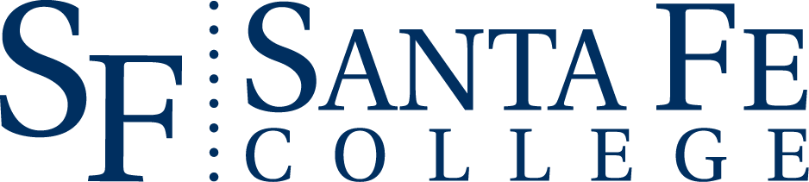

August 21, 2020
FOR IMMEDIATE RELEASE
CONTACT:
Jay Anderson, Communications Manager
Communications & Creative Services
jay.anderson@sfcollege.edu
352-381-3692

Santa Fe College to Honor Adjunct Faculty

Gainesville, Florida - Santa Fe College recognizes two adjunct faculty members with the annual Adjunct Excellence Award. This year’s honorees, Lanier Harper-Dickson and Amy E. Dautel, are being recognized for their dedication to the college, their profession, and the community.

Lanier Harper-Dickson, part of the English department, teaches College Composition I and II at the NW Campus. Lanier sees herself as a learner as well as an educator; she approaches her classes with the growth mindset philosophy that a student’s struggle “doesn’t automatically mean failure;” rather, students become agents of their own learning. Department Chair Melissa Flanagan praises Lanier for being “always willing to collaborate with her peers,” and calls her “enthusiasm for teaching…contagious.” Former President Jackson Sasser, after visiting one of her classes, commends her “warm and encouraging tone” and connection to students.
Amy E. Dautel provides a vital role to the Institute of Public Service and the community as a lead First Responder instructor in the Emergency Medical Service program. Amy feels that becoming a first responder, EMT, or paramedic is a “calling,” and it is the instructor’s duty “to make sure they are the most competent we can make them …before we send them out into the field.” Thomas Ackerman, Director of the IPS, extols Amy’s “positive can-do attitude” and says she exemplifies the high standards of IPS and SF. Former students call her “extraordinarily dedicated,” ‘positive,” and “encouraging.”
Congratulations to these fine educators!

About Santa Fe College
Founded in 1966, Santa Fe College (SF) is part of the Florida College System and a charter member of the prestigious League for Innovation in the Community College. SF has established programs and services that enable the college to carry out its mission of adding value to the lives of our students and enriching our community. The philosophy of the college has been, and continues to be student-centered. SF is home to a planetarium, a nationally recognized teaching zoo and a state-of-the-art Fine Arts Hall. SF also annually produces the Santa Fe College Spring Arts Festival, the largest cultural arts event in Alachua County. Visit sfcollege.edu for more information.

