- Relevant Motions

For discussion and vote at the 8/31/21 meeting:

Motion to the College Senate Executive Council regarding the enfranchisement of its part-time faculty and staff constituents

Whereas Santa Fe College's part-time faculty and staff provide services vital to the institution, in many departments delivering nearly half or more of the College's instruction;

Whereas the college administration made a direct and unequivocal appeal to its adjunct faculty to invest in shared governance rather than a "third party" union effort;

Whereas the Executive Council's three elected part-time representatives currently serve a constituency of roughly 550 constituents, as opposed to all other Executive Council representatives, who are elected on the basis of one representative for each fifteen College Senate members;

Whereas a recent survey of our constituents showed a strong preference for full membership in the College Senate;

Whereas the current constitution excludes its part-time faculty and staff constituents from membership in the College Senate and these employees are not empowered to run for Senate office, vote on its officers, nor to serve as voting members on Senate committees regardless of length of service to the college;

Whereas full-time faculty enjoy all these rights, regardless of length of service to the college; and

Whereas the stated purposes of the College Senate's constitution are to provide a means by which the membership may participate in the formulation of policies for the College; to promote cooperation for the improvement of the College and community; to provide a medium through which solutions to educational problems may be found; to provide opportunities for self-development and the exercise of initiative and leadership; to stimulate professional enthusiasm and spirit; to function as a liaison between the membership and other local, state, and national associations and programs; now, therefore, be it

Resolved that the College Senate Executive Council amend its Constitution to recognize those part-time faculty and staff who have completed 2,080 clock hours or 40 credit hours of service to the College (whichever comes first) as full members of the College Senate.

From 6/8/21
A motion very similar to Part 1 (from 4/13/21), again requesting data on part-time staff (see notes from Jay; motion carried). The remainder of the requested data is possibly still forthcoming.

From 4/13/21
Part 1) Human Resources and/or Payroll provide a one-time list of currently employed part-time faculty and staff, amended to include their total clock or credit hours of service to the College.(Carried 23-0-1)
This request was partially fulfilled by HR.

Part 2) That the College Senate amend its Constitution to recognize those part-time faculty and staff who have completed 2,080 clock hours or 40 credit hours of service to the College(whichever comes first) as full members of the College Senate. (Tabled until further data became available)

- Explanation of current motion

Currently, the 3 “adjunct reps” in the Senate Executive Council (EC) represent approximately 550 part-time faculty and staff. A plurality of our constituents would prefer to be full members of the College Senate and to be represented within their departments, as all of you are now.

However, in response to concerns some expressed about adding so many new constituents to the Senate, we put forth a compromise proposal that would enfranchise part-time faculty and staff only once they have worked at the college for 2,080 hours or 40 credit hours, whichever comes first. This threshold approximates one that the college was already using --participation in FRS for our part-time A&P staff and (formerly) participation in the fee waiver for both part-time A&P and adjuncts. This threshold would whittle down the 550 number significantly.

Decision Point: The Senate could choose to raise or lower that threshold, thereby enfranchising fewer, or more, part-time faculty and staff.

Per the HR list for Fall 2020, there were 551 part-time faculty and staff. Table 1 below reflects an approximation of the number of Senate constituents that would be added at the 2080/40 threshold (w/ total 551 reduced to 308; a 44% decrease). We then also doubled this to a 4160/80 threshold as a comparison (w/ total 551 reduced to 209; a 62% decrease).

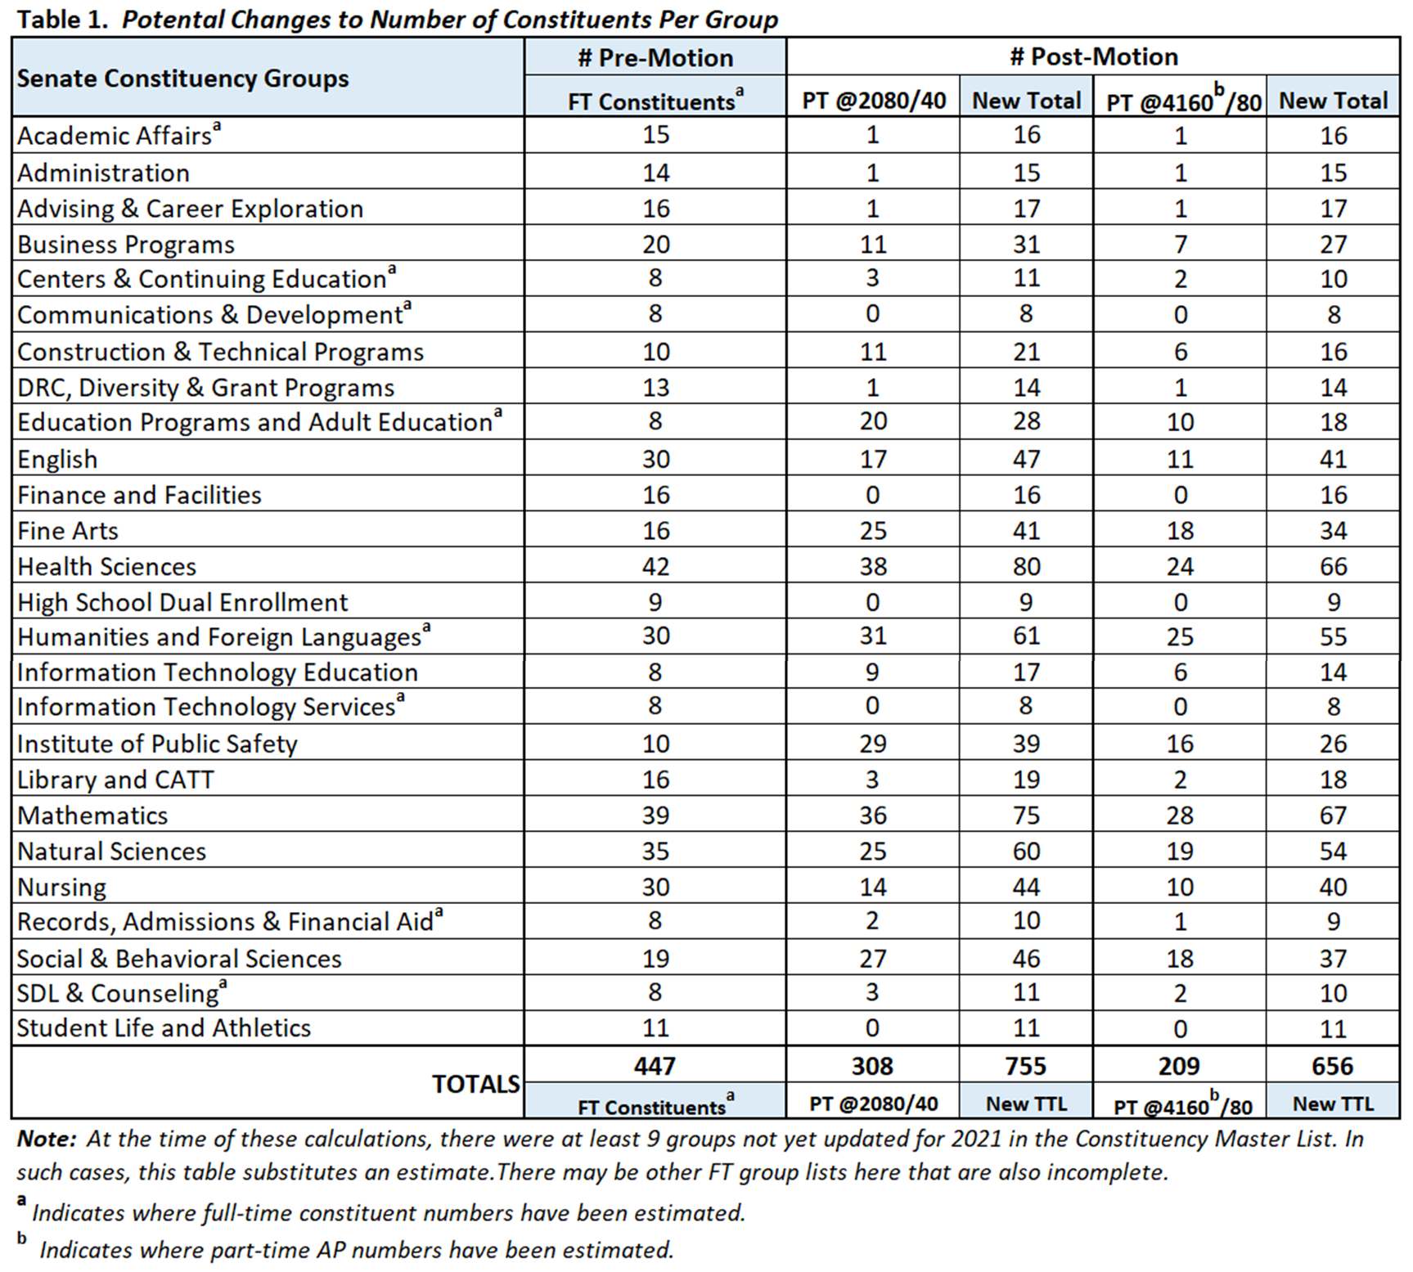

Once these new constituents have been enfranchised, some departments (for instance, those with a significant number of long-term part-timers) would gain more representatives on EC.

These newly enfranchised Senate members would then have the same rights as the rest of you: they could vote for College Senate officers, they could serve on the Executive Council in any capacity, and they could serve as voting members on Senate committees.

So, for example, if a department had many long-term part-time faculty or staff, that department might gain an extra representative or two on the Executive Council. Those representatives, serving both their full and part-time constituents, could themselves be either full or part-time faculty or staff. There is no requirement in what we are proposing that any Executive Council representatives must be part-time; your department would continue to choose who the representatives are in the same manner as you do now.

Table 2 below reflects an approximation of the number of Senate representatives that would be added to each constituency at both the 2080/40 and the 4160/80 thresholds. Per the Senate Bylaws, the number of representatives allotted per group in this table is “on the basis of one representative for each fifteen College Senate members, or major fraction thereof, with each group having at least one member” (e.g., +1 rep @8-15).
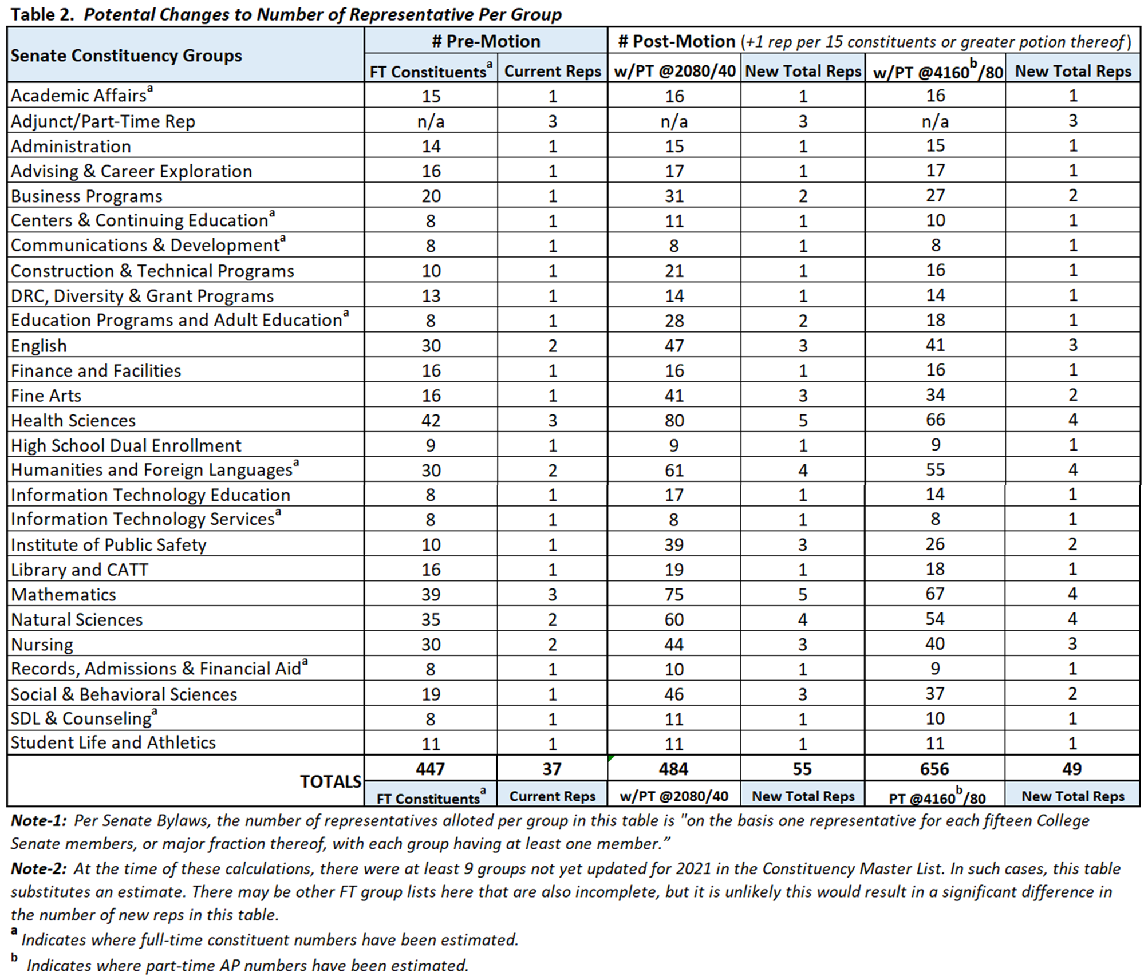
In our Motion, the constituents that we are recommending for enfranchisement are individuals who have spent years at the college and have demonstrated their investment and dedication to this institution. We support their desire for a greater voice in shared governance and believe that enfranchising them will not only serve the stated purposes of the College Senate but it will also strengthen the integrity of shared governance and the greater spirit of equity and inclusion on campus.

Decision Point: With this Motion, we have no interest in decreasing the representation of full-time members and have made no such recommendation. However, some have suggested that the Senate might choose to reapportion constituency sizes to add a more modest number of new EC representatives. Again, this is not what our Motion has suggested, but we have made some of those calculations in Tables 3 and 4 below for informational purposes.

Table 3 below reflects an approximation of the number of Senate representatives for each constituency at both the 2080/40 and the 4160/80 thresholds should the Senate decide to, for example, apportion representatives “on the basis of one representative for each seventeen College Senate members, or major fraction thereof, with each group having at least one member” (e.g., +1 rep @9-17).
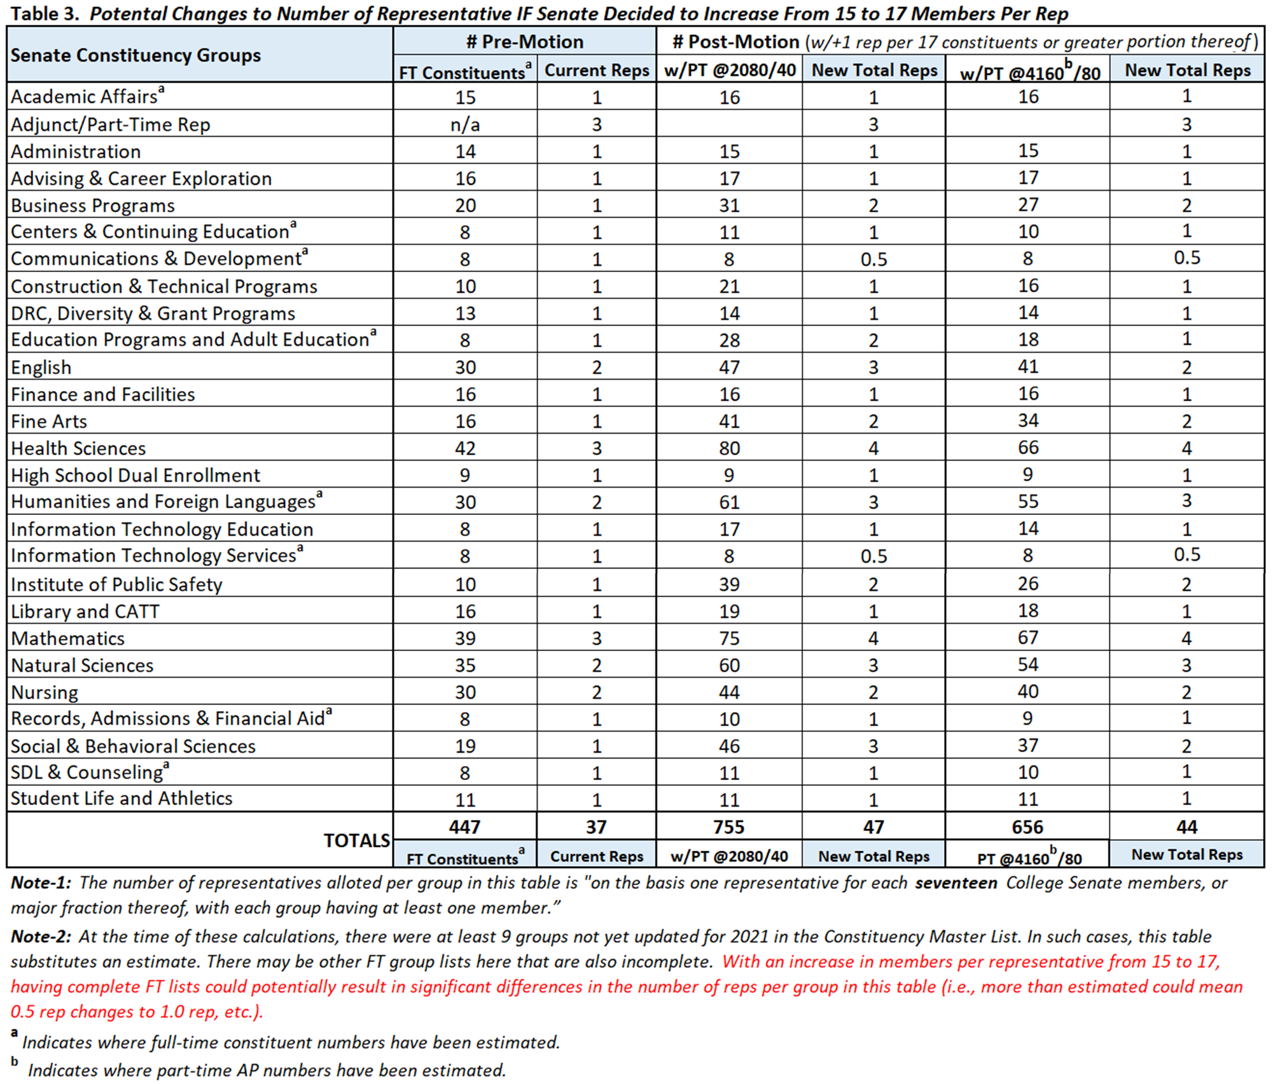

Table 4 below reflects an approximation of the number of Senate representatives for each constituency at both the 2080/40 and the 4160/80 thresholds should the Senate decide to, for example, apportion representatives “on the basis of one representative for each nineteen College Senate members, or major fraction thereof, with each group having at least one member” (e.g., +1 rep @10-19).

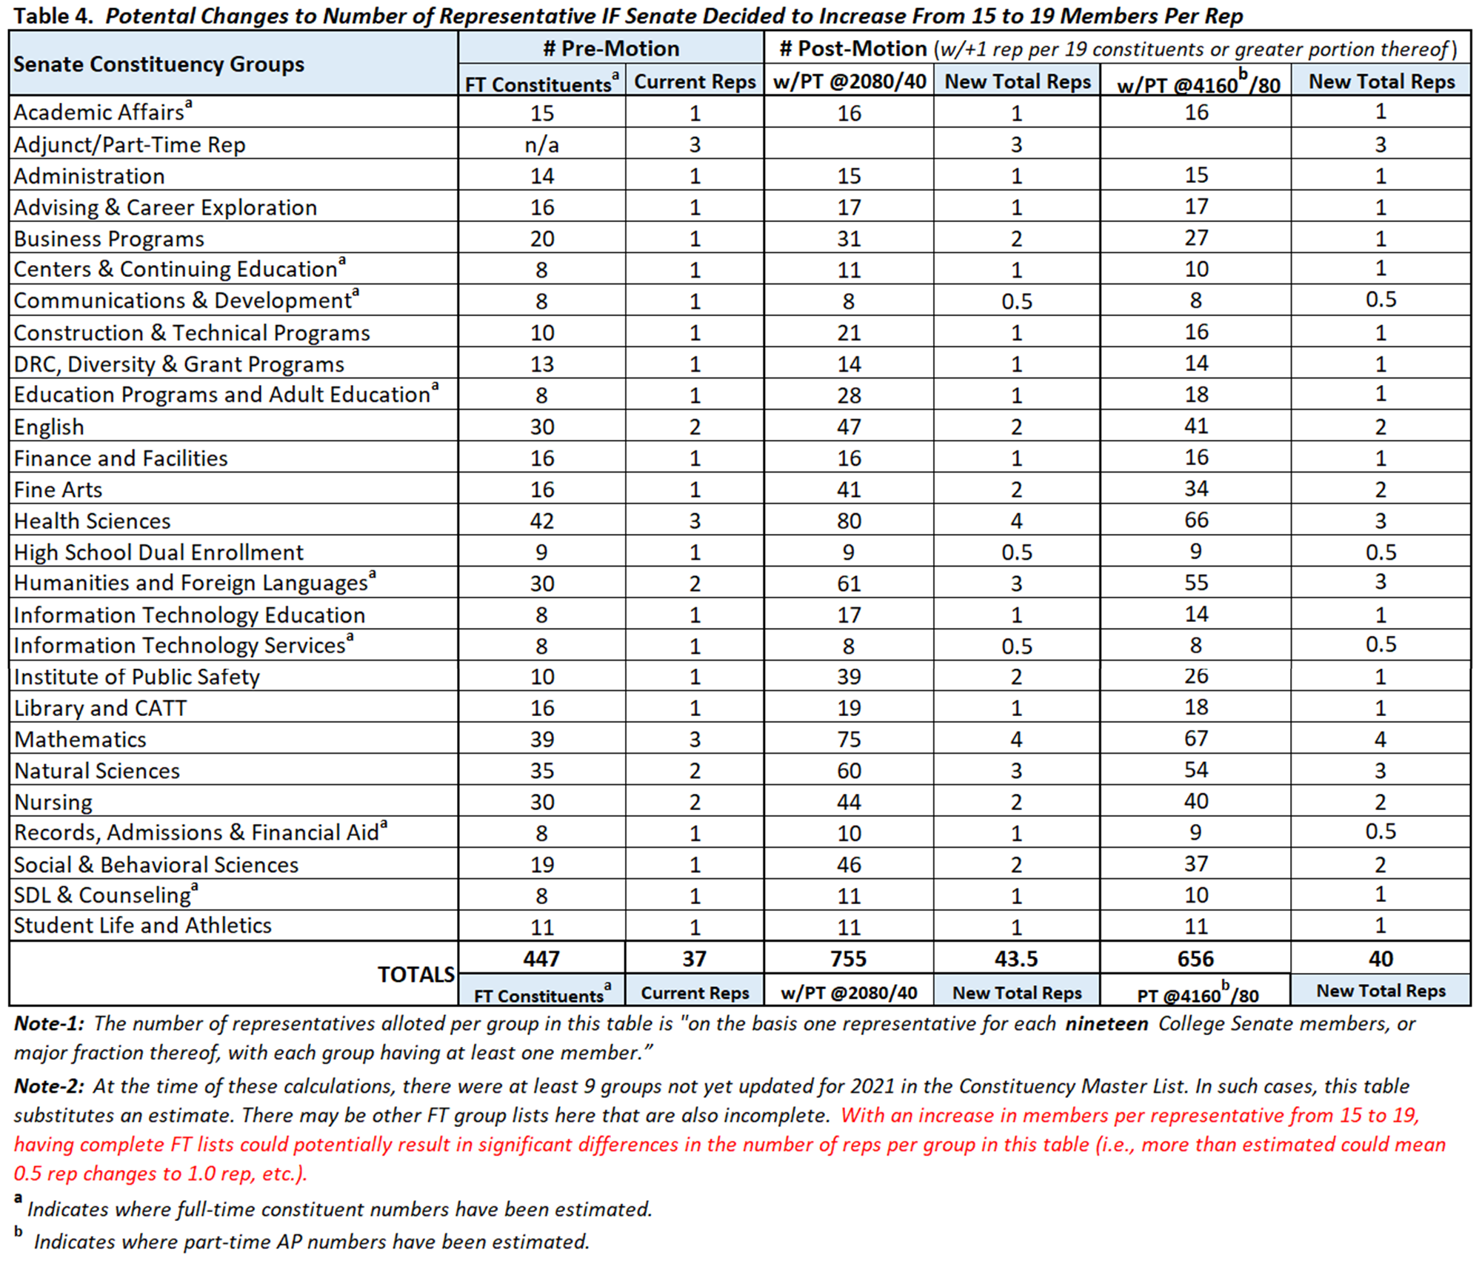

- Further Background

Throughout the College’s efforts to defeat the 2019 union drive amongst its adjunct faculty, President Sasser and other administrators made repeated pleas that part-time faculty instead turn to shared governance to resolve their grievances. Those of us who represent our part-time colleagues in the College Senate took that request seriously. In Fall 2019, the Senate formed an Ad-Hoc Committee, chaired by Jason Fults, with the goal of gathering survey data about our constituents’ views on participation in shared governance. Other committee members and participants included Dave Price, Ed Bonahue, Glynn Hayes, John Chamberlain, Katey Arnold, Kimberly Smith, Peter Concannon, Rebecca Johnston, Stacey Breheny, and Susan Warshaw.

The committee’s work was slowed and constrained by both COVID and by communication challenges with our constituents. However, the survey work was completed in early 2021 and the results were reported to the College Senate in Feb. and March of 2021. The survey showed a clear preference (45.3%) by our part-time colleagues for full participation in the College Senate, as opposed to the other options that were presented. When, after initial conversations with some Senate leadership, it became clear that a “one-person, one-vote” model was not going to gain sufficient votes, we brought forward a compromise motion that would only enfranchise our part-time colleagues after more than one year of service at the college. Given continued pushback against even that compromise proposal, along with requests for more specifics on how exactly the motion would impact existing constituencies, we made requests for more data so that we could more accurately report that information. With this document, based on the data we’ve been provided, we’ve worked to respond to the Senate’s request and provided further details.

